**Ultrasonic Casting Sand Removal System MARS-CSR**

**Subject to casting sand removal**

　　　　　　Casting sand removal for casting aluminum, FC, etc. Casting sand removal equipment for engine heads, blocks, oil pans, manifolds, valve bodies, hydraulic equipment, etc. for passenger cars and trucks.

The size varies, but in the case of engines, we have set the standard for equipment that can simultaneously process two 650mm x 300mm x 200mm pieces in two minutes, as we began receiving orders for casting sand removal equipment for F1 no. 1 engines.

Of course, we can also accommodate non-standard items, from small to larger ones.

　Ultrasonic casting sand removal is performed by placing the casting in water before and after

The air around the casting sand is removed by vacuum treatment, and our unique frequency

Our unique technology that irradiates powerful ultrasonic waves from the outside to remove casting sand from the inside of the casting machine.

Technology.

**Principle of vacuum [pretreatment type] ultrasonic casting sand removal and cleaning system**

　　　　　　If the shape is complex and air does not escape easily when immersed in liquid, a vacuum is required.

The engine block, for example, is a complex labyrinth. Engine blocks, for example, have a complex labyrinth of cavities inside, so simply immersing the object in the cleaning solution does not allow all of the air to escape. Air bubbles and air bubbles in the surface layer of the object, such as in the stop holes or in the sintered metal, greatly affect the shape of the cavity. In other words, a gas nebula type cavity is generated. This means that casting sand cannot be removed.

In addition, small bubbles reflect ultrasonic waves or absorb changes in sound pressure, causing cavitation or absorbing and mitigating its positive and negative shock waves. In other words, they reduce the cleaning effect. The dense generation of spherical nebula-shaped cavities is absolutely necessary for the removal of casting sand. Therefore, the majority of precision cleaning applications with complex geometries inherently require this vacuum pretreatment cleaning system.

　Of course, the prerequisites for this are the basic design conditions, such as the shape of the cleaning tank, which allows cavity control, and the proper flow and depth of the liquid.

　The introduced water must be maintained at the desired dissolved air content in a stable manner. In other words, a cavitation enhancement system is also essential.

　By doing these things correctly, the influence of air can be eliminated and ultrasonic cleaning can be performed.

Of course, for simple shapes, direct powerful and ultrasonic cleaning is fine.

**Example of simultaneous removal of casting sand from two engine blocks Model MARS-CSR-4L**

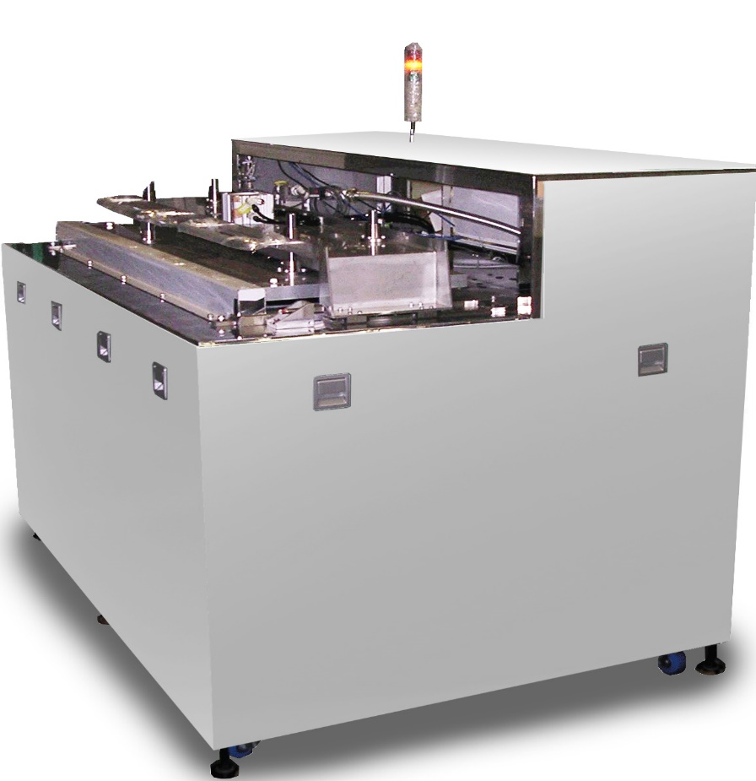

　　After vacuum pretreatment, one or two engine blocks are placed side by side,

It is introduced into the ultrasonic cleaning tank. Ultrasonic transducers on both sides, parallel and opposed to each other.

They are lined up. One side is 7200W 4W/cm2 . The distance between the diaphragms is

A resonance synchronous circuit is built to match the design value. The basic frequency is 25 KHz.

It is a simultaneous wide-area multiplexed wave that synergizes high-frequency portions up to 275 KHz.

　Tank width, liquid depth, liquid flow, and temperature distribution are Cavitation is stable

The design of the system is such that it can be easily generated and controlled.

When oscillating, 7200W x 2 units = 14,000W 4W/cm2 powerful cavities

tation distribution.

This ultrasonic wave is not affected by air and causes powerful vibrations in the engine block.

The large spherical cavities (spherical nebula shape) are created by the rubbing and reaching inside.

The casting sand is ejected and hard, sticking or stuck casting sand is removed in a short period of time.

　Removal time is approximately 2 minutes for two 2000cc class vehicles.

　In addition, experiments with higher speeds are underway.

**Processing of casting sand**

Casting sand is heavy, and most of it settles to the bottom of the tank. With the help of ultrasonic vibration, it is collected from the drain port into the casting sand storage tank and disposed of.

　Fine, slightly suspended casting sand is sucked in by a circulation pump and collected and removed by a liquid cyclone system.

