Special Feature: The Forefront of Devouring Technology

1. at the beginning

Ultrasonic deburring and cleaning technology is one of the cavitation application technologies generated by ultrasonic waves.

Hence, we would like to first review ultrasonic cleaning technology.

Ultrasonic cleaning is a cleaning method that emits powerful ultrasonic waves into a liquid and uses the impact force generated when cavities are created and extinguished. If cavities are not generated, it cannot be called ultrasonic cleaning. Therefore, the basic requirement for understanding and effectively using ultrasonic cleaning is to correctly understand cavities and the phenomena of cavity generation and annihilation (cavitation).

A liquid is irradiated with powerful sound waves above 20 kHz, i.e., ultrasonic waves. When a sound pressure change above a certain level occurs in the liquid, so-called cavities are generated; one cavity is composed of many smaller vacuum nuclei (microcavities).

Hence, I also refer to cavities as microvacuum nuclei groups.

When a liquid with a dissolved air content of 20 mg/ℓ or more of dissolved oxygen is irradiated with ultrasonic waves, countless bubbles are generated. These bubbles are not cavities, but simply air bubbles, and are merely a defoaming phenomenon caused by ultrasound. These bubbles are generated on the surface of the ultrasonic diaphragm, and 99.9% of ultrasonic waves are reflected and eliminated. Therefore, if one wants to use ultrasonic cavities in liquids other than water, the dissolved air content must first be kept below about 8 mg/ℓ of dissolved oxygen.

2. dissolved oxygen content and cavity shape

　In 1993, he presented at the International Conference on Ozone Layer Protection in Washington, D.C., that cavities generated by ultrasound can be divided into two main shapes.

2.1 Gas Nebula Cavity [Photo 1]

Dissolved oxygen content is approximately 4 mg/ℓ or higher,

* Blue Star R&D Inc:

1-31-1 Yokoyamadai, Chuo-ku, Sagamihara-shi, Kanagawa 252-0241

Date of receipt of the conference: Month and day of 2017

Cavities generated by ultrasound consist of a vacuum nucleus of about 0.5 mm and a collection of numerous smaller vacuum nuclei, which are not distributed spherically but are distributed in a scattered manner parallel to the ultrasonic diaphragm. Because of their shape, cavities of this shape are called gas nebula cavities.



Photo 1: Gas Nebula Cavity

2.2 Spherical Nebula Cavity [Photo 2]

When the amount of dissolved oxygen is kept below 3 mg/ℓ, the cavities generated by ultrasound become spherical in shape with an outer diameter of 3 to 10 mm, with multiple vacuum nuclei of 1 mm or larger gathered in a dense state. This cavity is called a spherical nebula. These spherical nebula cavities move at a high speed of 100 m/sec perpendicular to the diaphragm, whereas the gas nebula cavities are distributed horizontally in a straight line on the ultrasonic diaphragm.

Ultrasonic deburring cleaning is an applied technology of this spherical nebula-shaped cavity.

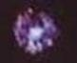

Photo 2: Spherical Nebula Cavity

3. principle of ultrasonic deburring cleaning - summary

When using 25 kHz ultrasound, the cavity [a group of microvacuum nuclei] reaches its maximum shape in approximately 5,000ths of a second after the onset and disappears in the next 5,000ths of a second. This is repeated 25,000 times per second. In the case of a spherical nebula cavity with a diameter of 10 mm, this means that a liquid volume of 10 mm in diameter moves away from the center of the cavity at high speed in 1/50000 of a second. I call the shock force generated at this time a positive shock wave. In the next 5,000th of a second, the cavity disappears. This means that the liquid outside the vacuum core with a diameter of 10 mm reaches the cavity center in 1/5000th of a second. The shock wave generated at this time is called a negative shock wave.

When measured accurately, the speed of cavity generation and annihilation are not the same; annihilation is about 20% faster. In other words, the negative shock wave is larger.

Therefore, since the total impact energy of the cavity is due to the high-speed movement of the liquid, its kinetic energy is proportional to its mass and to the square of its velocity, which in this case can be said to be proportional to the third power of its diameter and to the square of its diameter if the travel time is the same. Of course, it is not that simple, since a single cavity is a collection of smaller vacuum nuclei, but it is clear that the size of the cavity has a significant effect on the magnitude of the positive and negative impact forces.

seven (used in legal documents)

6)

Spherical cavity growth

Ultrasonic deburring and cleaning technology removes burrs from their roots by stress fracture through the repetition of positive and negative shock waves - pushing and pulling - 25,000 times per second by spherical nebula-shaped cavities attached to the burrs.

Growth limit of spherical cavity

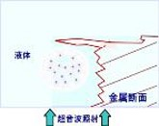

(i)

Spherical cavity generation

0sec/50000

6~10mm dia.

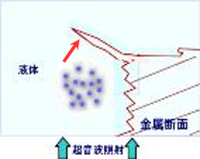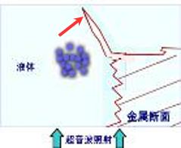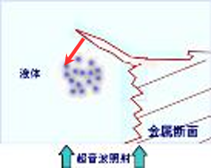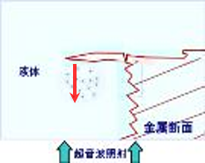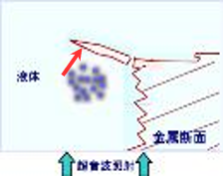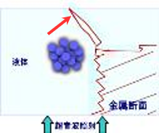

Spherical cavity reduction

1.5sec/50000

Disappearance of spherical cavities

2sec/50000

4)

(iii)

(2)

Spherical cavity growth

0.5sec/50000

Growth limit (maximum point) of spherical cavity

1sec/50000

increasing pressure

decompression

microcavity

［Fig. 1] Remove stuck burrs by pulling them out.

Deburring process of ultrasonic deburring

See **Figure** 1.

　This figure is a simple illustration of the image taken by a high-speed camera in 1993, and its behavior is explained in detail below.

The frequency of the ultrasound is 25 kHz.

(1) Cavity generation: Microcavity nuclei begin to appear in an average distribution in a space of approximately 6 to 10 mm in diameter.

Microcavities grow at that location with little change in position from the cavity center.

Microcavity growth: Microcavities grow individually and push away surrounding liquid at the same time. The pushed liquid moves at high speed to the periphery of the cavity. Shock waves generated at this time move away from the central nucleus (positive shock waves).

(3) Growth limit of microcavities: Microcavities grow with little change in position from the center until they reach a size where they collide with each other. The microcavities stop growing at this point. The shape of the microcavity assembly at this point is spherical with a diameter of 6-10 mm.

Shrinking microcavity: The microcavity shrinks without changing its position from the center. At this time, the liquid around the cavity moves toward the center. At this time, the burrs are subjected to a pulling force opposite to the previous one (negative shock wave). （Negative shock wave)

5)

(5) Annihilation of microcavity: Microcavity disappears and the space where the cavity existed is filled with liquid. The liquid inside the cavity moves in a very complicated manner, while positive and negative shock waves are generated outside the cavity as it grows and disappears. Pushing and pulling forces are alternately generated on the burrs; the process repeats 25,000 times per second. Comparing the time from generation to the growth limit and the time from the growth limit to extinction, the time to extinction is clearly faster. This is due to the effect of water pressure plus atmospheric pressure. Therefore, a negative shock wave is more powerful than a positive shock wave in the vicinity of the cavity. If both forces were the same, ultrasonic cleaning would not be possible. One of the main features of ultrasonic deburring is that it causes burrs that are stuck to the surface to be removed from their roots.

The size of the spherical nebula cavity used for deburring is 6 to 10 mm in diameter, and the fundamental frequencies used are 20 kHz and 25 kHz. In our case, the two fundamental frequencies are simultaneously oscillated with their respective overfrequency components.

The oscillation method called "simultaneous multiple wave" is used to reduce cavity generation irregularities. Water is the most commonly used liquid, but other liquids such as rust inhibitors, hydrocarbons, and other solvents are used according to the purpose.

4. Deburring Examples

As can be seen from the principle, the target of ultrasonic deburring is any material. The target materials for ultrasonic deburring are metals, plastics, ceramics, and their composite materials, including burrs from precision machining and molding, with a standard thickness of approximately 0.1 mm at the base of the burr.

There are no practical examples of burrs in rubber or soft materials such as silicone. Many plastics are also hard materials such as PPS.

Deburring cleaning time ranges from less than 30 seconds to about 30 minutes. The deburring time is determined by the thickness of the root of the burr and other factors.

The number of pieces processed at one time can range from one piece to tens of thousands of pieces to meet customer needs. **[Photo 3]**

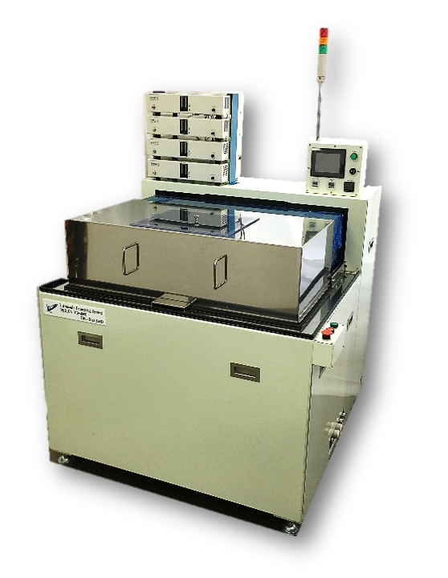

［Example of standard machine Photo 3]

Please see the following case study photos.

These are images of typical materials before and after deburring.

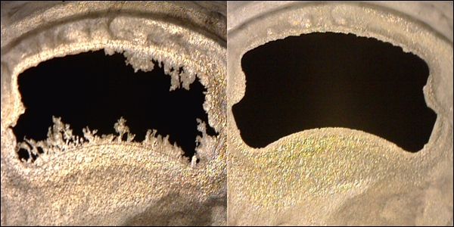　 PPS molding process burrs [Photo 4]

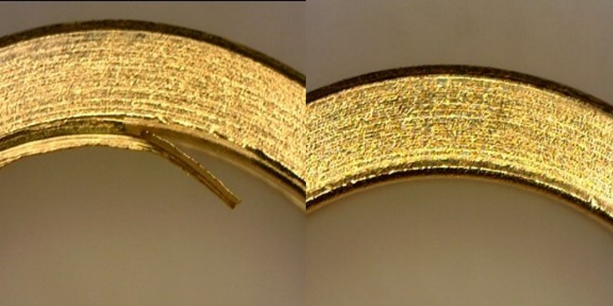

SUS burr [Photo 5]

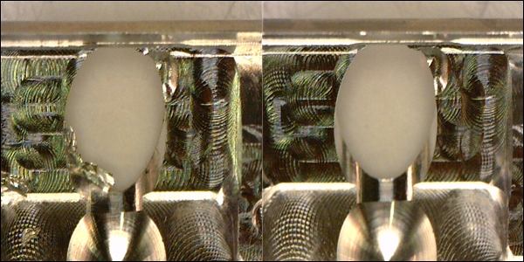

Aluminum cutting burrs [Photo 6]

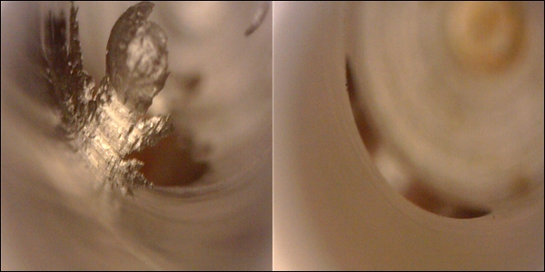

Iron Cross-hole burr [Photo 7].

Ultrasonic deburring systems are supplied to a very wide range of customers, including automotive parts, semiconductor parts, smart phones and other communication device parts, aircraft parts, medical parts, semiconductor parts, and textile-related parts.

5. Introduction of application examples of ultrasonic deburring

With the spread of ultrasonic deburring, various applications have been reported, and standardization is being promoted through verification.

Two examples are presented below.

5.1 Ultrasonic barrel finishing

　Without media such as stones, 3,000 to 25,000 target workpieces are simply placed in a hexagonal rotating basket in water under deburring conditions, and then irradiated with ultrasonic waves. The purpose was to improve the efficiency of deburring, but it was confirmed that the machine was also capable of polishing, and it has been automated as an ultrasonic barrel finishing machine and is beginning to be widely used. ［**Photo 9] shows** an ultrasonic deburring, polishing, cleaning, and drying machine for bearing retainers.

Since no media is used, no post-cleaning is required and workers are freed from heavy labor. In addition to the impact force of the cavity, the synergistic effect of the co-dragging effect of 25,000 times per second has been confirmed to more than double the polishing speed of ordinary barrel polishing.

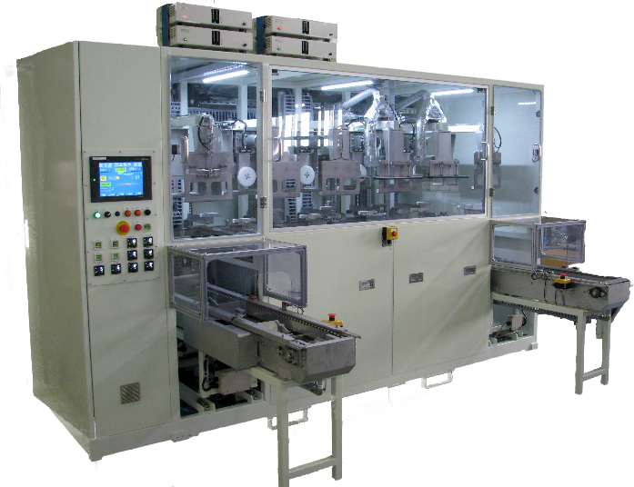

［Photo 8] Ultrasonic deburring, polishing, cleaning and drying equipment

5.2 Ultrasonic field deburring

　This is done by connecting a number of objects to the minus electrode and irradiating them with ultrasonic waves for deburring while an electric field is applied. This is effective for removing resin burrs adhered to metal, such as molding burrs on lead frames.

6. Features of ultrasonic deburring cleaning

　Ultrasonic deburring has many unique features. It is a new means of processing that reduces labor costs, stabilizes quality, and lowers costs by automating the process.

1. No choice of material

Basically, it can handle almost all materials, including metals, plastics, ceramics, and their composites, although there are some degree of difficulty.

2. Unconstrained by shape

Burrs occur in multiple directions, including tolerance holes on the inner surface.

3. Not limited in number

From one to tens of thousands of pieces can be processed at a time or in succession.

4. No hazardous materials are generated

Hazardous materials are not used and, in principle, water is used.

5. Burrs can be removed while cleaning without contaminating the material to be cleaned.

At the same time, precision cleaning is possible.

6. No special technology or skills are required for use.

Easy to automate and therefore easy to manage.

7. Micro burrs (micron size) can be removed more quickly and reliably.

It is the only deburring method that can be used for future ultra-precision machining.

8. Low consumables

Unlike other means, daily maintenance is not required, and the only consumable is the filter, so running costs are low.

9. Low equipment costs

The system is far less expensive than other competing methods that require precision ultrasonic cleaning after deburring.

10. Drying can also be made into a line.

Suitable for processing air for precision parts, with little re-adhesion of stains.

11. No need for isolated deburring, cleaning rooms, etc.

The above advantages mean that they can be installed in a clean room or other environment, and do not require isolated deburring and cleaning rooms, as other means do, reducing administrative costs.

7. The Future of Ultrasonic Deburring Technology

The movement to view cavities generated by ultrasonic waves as a new machining tool seems to be quietly spreading. Cavitation processing technology, when utilized for deburring, requires a variety of measures to ensure that more powerful and larger cavities are generated in a stable manner and that the ultrasonic chamber is not destroyed to maintain a stable cavitation distribution in the chamber used. In order to guarantee stable cavity generation over a long period of time, large ultrasonic vibration elements dedicated to deburring have been developed, and circuits have been developed to enable 50 to 200 vibration elements to oscillate stably and synchronously.

The practical output power ranges from 600W to 21,000W.

Ultrasonic diaphragm management, maintenance, and repair techniques are also undergoing major changes.

We are confident that ultrasonic deburring technology will continue to evolve steadily, accompanied by the development of peripheral control technologies.