**Industrial ultrasonic deburring and cleaning equipment**

**Larger spherical nebula cavity and latest ultrasonic deburring cleaning**

　　　　　　　　　　　　　　　　　　　　　（Blue Star R&D Co.

　　　　　　　　　　　　　　　　　　　　　　　　　　　　　　　　　　Yoshihide Shibano

**1. at the beginning**

Ultrasonic deburring and cleaning technology is one of the cavitation application technologies generated by ultrasonic waves.

Hence, we would like to first review ultrasonic cleaning technology.

Ultrasonic cleaning is a cleaning method that emits powerful ultrasonic waves into a liquid and uses the impact force generated when cavities are created and extinguished. If cavities are not generated, it cannot be called ultrasonic cleaning. Therefore, the basic requirement for understanding and effectively using ultrasonic cleaning is to correctly understand cavities and the phenomena of cavity generation and annihilation (cavitation). Of course, the same is true for ultrasonic deburring technology, which is an application of ultrasonic cleaning.

The difference between general ultrasonic cleaning and ultrasonic deburring is that in the case of cleaning, the target part is a surface foreign matter that adheres or sticks to the surface, whereas in the case of deburring, the target part is physically connected to the target solid, and the materials are basically the same, although they may be altered by heat or pressure.

　The object to be cleaned is not physically connected to the body, while the object to be deburred is connected to the target solid. Therefore, the cavities used are naturally different.

**2. ultrasonic deburring cavity features**

　　　Ultrasonic cleaning or one of its applications, ultrasonic deburring, is a technology that applies the positive and negative impact forces generated by ultrasonic waves when cavities are created and extinguished, as described above.

　Its energy relies on the kinetic energy of the liquid, which moves instantaneously during the creation and annihilation of cavities. Since ultrasonic deburring is a technique for cutting solids (burrs) that are considered unnecessary due to the impact force of ultrasonic cavities, the cavity to be sought is obvious for the same frequency and liquid quality.

Ultrasonic deburring cleaning cavities must be spherical and larger in diameter.

**[800]**

**(1) Cavity creation and annihilation**

　　　The following pictures are images of cavities generated by a 2.1 millionths high-speed camera irradiated with 25 KHz ultrasonic waves. The time from generation to disappearance is 1/50,000 of a second. The diameter of this cavity is about 8 mm.

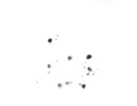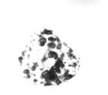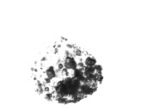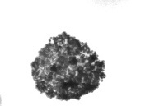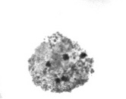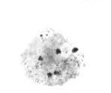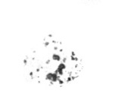

　　　A shock wave (positive shock wave) is generated outward from the central core of the cavity at the onset and dissipates

　　　Shock waves (negative shock waves) are generated from the outside toward the center core. These positive and negative shock waves, which repeat more than 50,000 times per second, remove burrs and clean the surface.

**(2) Removal of contamination by cavity**

　　　　　　A 2.1 millionth of a second camera captures 　　　　　　images of dirt being removed by 25 KHz ultrasonic waves,

I dropped in the image.

　　　　The following is an 　　　　image of the new system, which has been edited for clarity.

　　　　It takes about 15 seconds from start to finish.

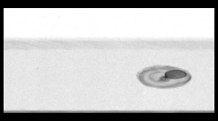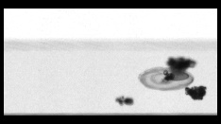　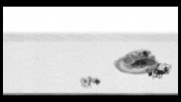　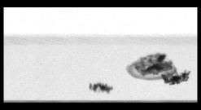　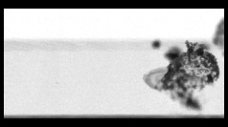

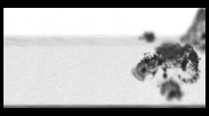　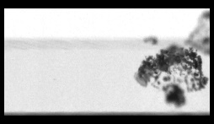　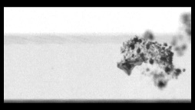　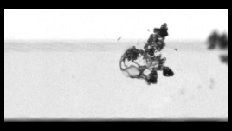　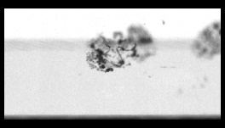

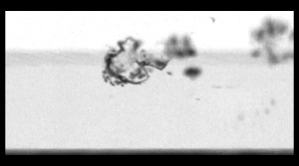　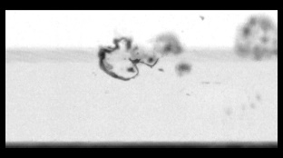

　　Since we have only just started filming, we have not yet been able to capture enough clear images.

We hope to release a video of the moment of burr removal in the near future.

　However, the cavity shape required for deburring is obvious.

　　Ultrasonic deburring cavities (microvacuum nuclei) should be spherical in shape. Its diameter is,

6mmΦ or larger, 10mmΦ or larger. Although we have not yet succeeded in stable generation of cavities larger than 12mmΦ,

We believe that there is a good possibility.　　　　　　　　　　　　　　　　　　　　　　　　　　　　　　　　**(550)**

**3. Example of ultrasonic deburring cleaning**

As can be seen from the principle, the target of ultrasonic deburring is any material. The thickness of the burr at the base of the burr is approximately 0.1 mm.

Although there are still few practical examples of burrs from soft materials such as rubber and silicone, the number of burrs from these materials is steadily increasing. Plastics are mostly hard materials such as PPS.

Deburring cleaning time ranges from less than 30 seconds to about 30 minutes. The deburring time is determined by the thickness of the root of the burr and other factors.

The number of pieces processed at one time can range from one piece to tens of thousands of pieces, depending on the customer's requirements.

1. **Standard machine series for ultrasonic deburring and cleaning**

　The company offers more than 300 models of standard machines, ranging from small to large, fully automatic machines.

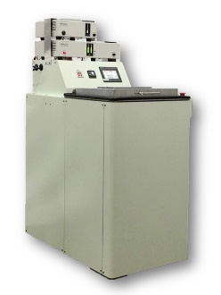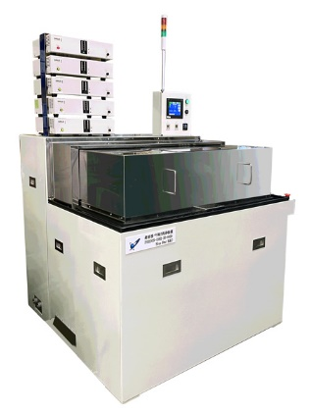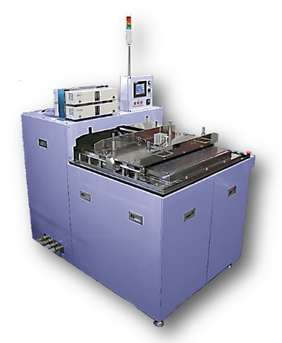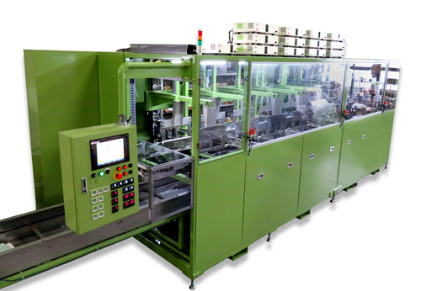

StaBaby OERION MARS VEGA

1. **Specialized machine for ultrasonic deburring and cleaning Examples**

Most standard machines line up workpieces in baskets and place them in an ultrasonic tank, where ultrasonic waves are applied from below. The following is an example.

1. Ultrasonic diaphragm moving type

　　B. Type in which a vibrating plate for throwing in is placed at the bottom of the object to be deburred and cleaned and run.

　　　Cost reduction method when the object is long and there is enough time for cleaning.

　　B. Type that moves the ultrasonic diaphragm horizontally above the object, just above the surface of the water

　　　　The object is very large and heavy (e.g., several tons of mold) and the object to be cleaned is on top.

　　C. The object is clamped between the ultrasonic diaphragms on both sides and travels inside the tank in synchronized resonance.

　　　　Cost reduction measures in large anodizing tanks for deburring, etc.

1. An automatic line that directly fires ultrasonic vibrating plates on top of objects conveyed on a conveyor.

　　　　　Remove burrs by direct irradiation from the top to remove and clean burrs by countermeasures against attenuation of ultrasonic waves by conveyors, baskets, etc. when irradiating from the bottom.

1. Continuously stamped parts such as hoops, electronic parts, and composite materials are irradiated intensively between the front and rear reels.

　Burr. can run 1, 2, or 3 series **(770)**

The following is a list of the most common problems with the

1. **Ultrasonic deburring cleaning Target case**
   1. Before and after images of typical materials before and after deburring (plastic)

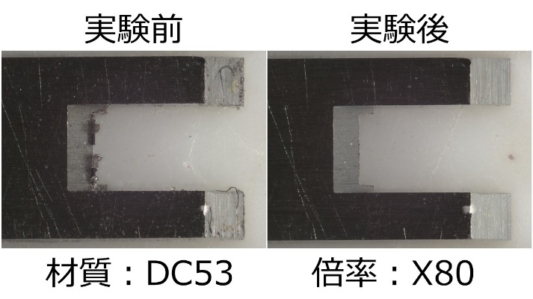　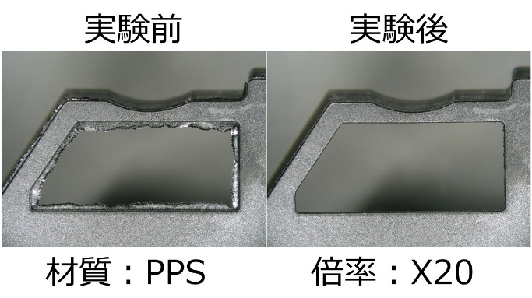

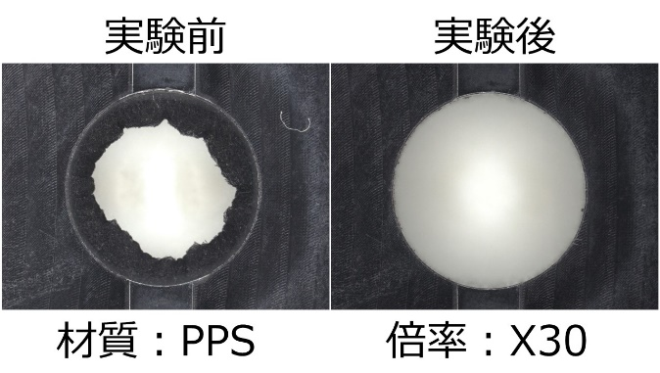　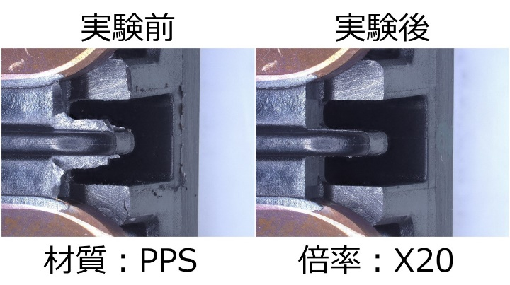

* 1. Images of typical materials before and after deburring (die casting)

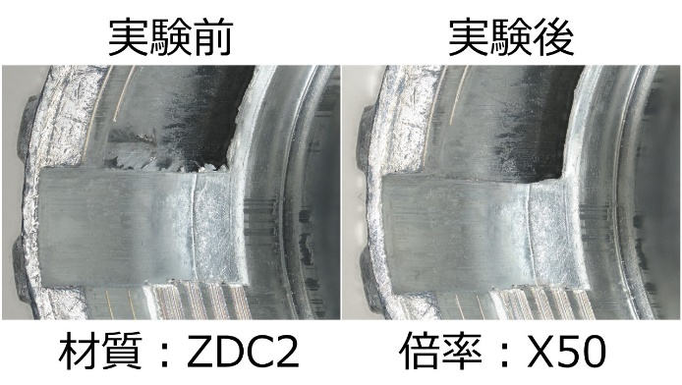　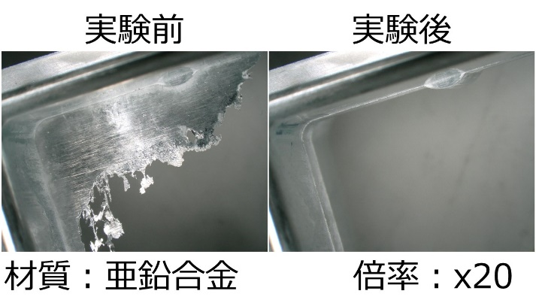

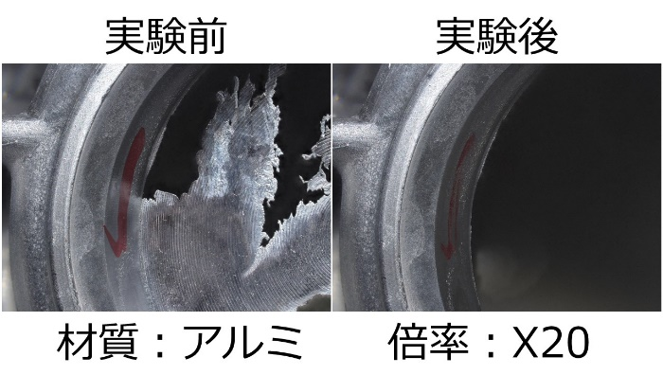　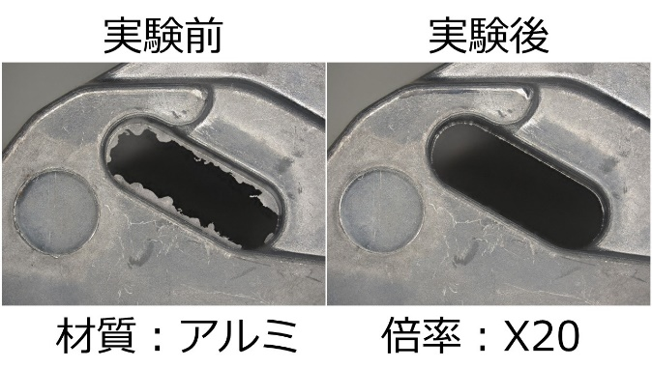

* 1. Before and after images of typical materials before and after deburring (others)

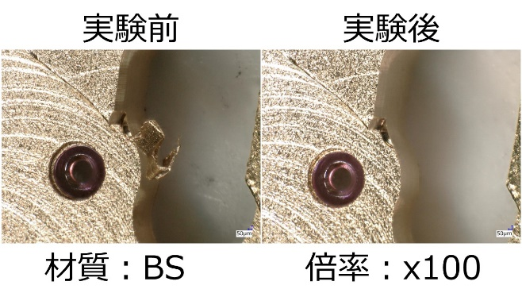　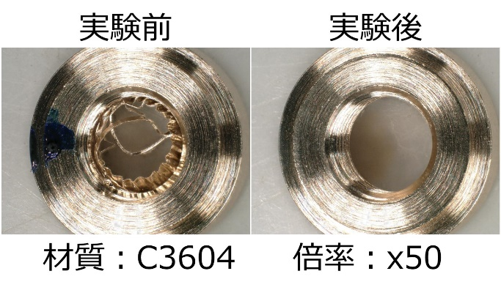

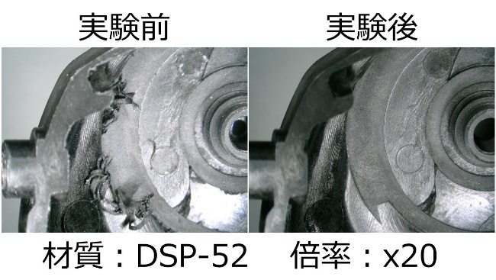　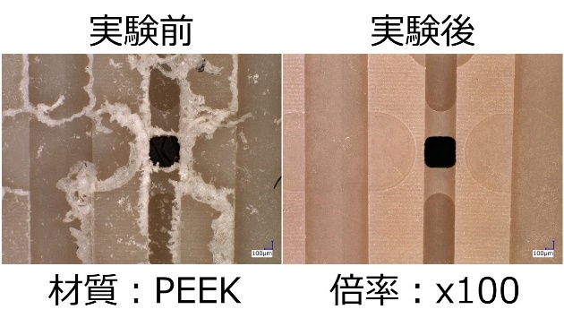

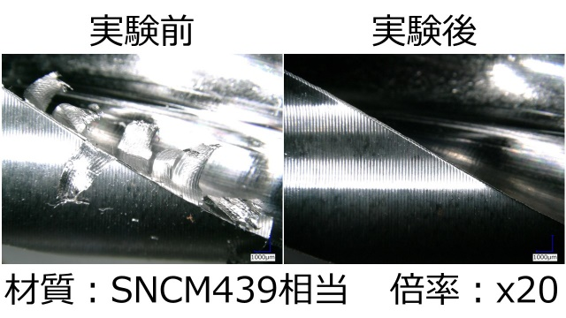　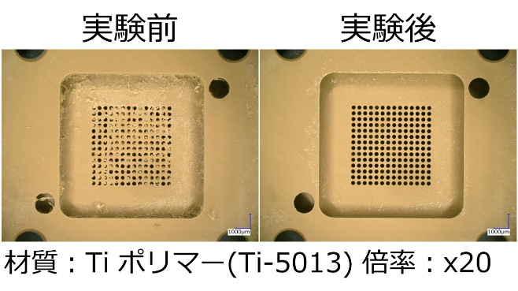

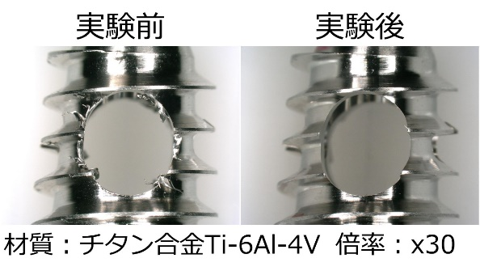　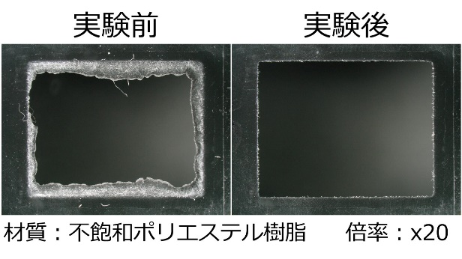

The ultrasonic deburring systems are supplied to a very wide range of customers, including automotive parts, semiconductor parts, parts for smartphones and other communication devices, aircraft parts, medical parts, semiconductor parts, and textile-related parts.

Currently, the number of countries to which we deliver our products is spread across China, South Korea, Taiwan, the Philippines, Vietnam, Thailand, Indonesia, Turkey, Portugal, France, Hungary, and the United States.

**4. Features of ultrasonic deburring cleaning**

　Ultrasonic deburring has many unique features. It is a new means of processing that reduces labor costs, stabilizes quality, and lowers costs by automating the process.

1. No choice of materials

Basically, it can handle almost all materials, including metals, plastics, ceramics, and their composites, although there are some degree of difficulty.

(2.) Unconstrained by shape

Burrs occur in multiple directions, including tolerance holes on the inner surface.

3) . Not limited in number

From one to tens of thousands of pieces can be processed at a time or in succession.

(4.) No hazardous materials are generated.

Hazardous materials are not used and, in principle, water is used.

(5) Burrs can be removed while cleaning without contaminating the cleaned material.

At the same time, precision cleaning is possible.

(6.) No special skills or techniques are required for use.

Easy to automate and therefore easy to manage.

(7.) Micro burrs (micron size) can be removed more quickly and reliably.

It is the only deburring method that can be used for future ultra-precision machining.

8.) Low consumables

Unlike other means, daily maintenance is not required, and the only consumable is the filter, so running costs are low.

9.) Low equipment costs

The system is far less expensive than other competing methods that require precision ultrasonic cleaning after deburring. Significant reductions in labor costs can be expected.

10) . Drying can also be made into a line

Suitable for treatment of air from precision parts processing due to low re-deposition of stains.

11) . No need for isolated deburring, cleaning rooms, etc.

The above advantages mean that they can be installed in a clean room or other environment, and do not require isolated deburring and cleaning rooms, as other means do, reducing administrative costs.

**10. The Future of Ultrasonic Deburring Technology**

The movement to view cavities (micro vacuum nuclei) generated by ultrasonic waves, which can reach as large as 10 mm in diameter, as a new machining tool seems to be quietly spreading. Cavitation processing technology, when utilized for deburring, is a technology that stably generates a myriad of more powerful and larger cavities. In addition to ultrasonic cleaning, ultrasonic deburring, and ultrasonic etching, I see potential in new areas such as the promotion of chemical reactions and the modification of solid surfaces.

We are confident that ultrasonic deburring technology will continue to evolve steadily, accompanied by the development of peripheral control technologies.　　　　　　　　　　　　　　　　　　　　　　　　　　　　　　　　　　　　　　　　　　　　　　**(700)**