Latest Ultrasonic Cavitation Application Technology

Deburring, polishing, casting sand removal

　　　　　　　　　　　　　　　　　　　　　　　　　　　　　　　　July 13, 2019

　　　　　　　　　　　　　　　　　　　　　　　　　　　　　　　　　（Blue Star R&D Co.

　　　　　　　　　　　　　　　　　　　　　　　　　　　　　　　　　　Yoshihide Shibano, Chairman

　　Ultrasonic cavitation application technology has made great progress over the past few years. The diameter of cavities (microvacuum nuclei) generated by ultrasonic waves has changed from 0.5 mmΦ in conventional ultrasonic cleaning to nowadays, huge cavities with a diameter of 10 mm are available. The impact energy is cubic times the diameter.

As a result, many things that were previously thought to be impossible, such as ultrasonic deburring technology that simultaneously deburrs and cleans, ultrasonic barrel polishing technology that simultaneously deburrs, polishes, and cleans using only water, and removal of various types of casting sand, have been put to practical use one after another and are used both in Japan and overseas.

**1. What is ultrasonic cleaning?**

A major reason for the 30-year stagnation of ultrasonic cleaning technology is due to a misunderstanding of the basic understanding of what ultrasonic cleaning is. Ultrasonic cleaning systems have made rapid progress in accordance with advances in peripheral technologies and user demands. Transport technology, instrumentation technology, and sheet metal welding technology. However, there has been no significant change in the basic content of ultrasonic cleaning technology, with a few exceptions. Even though the appearance and transport technology have changed, ultrasonic cleaning technology cannot meet the demands of the times unless there is a fundamental innovation in ultrasonic cleaning technology.

In order to fully utilize the innovative ultrasonic cleaning technology for the new era, it is first necessary to have a deep understanding of what ultrasonic cleaning is, why it removes dirt and why it does not, and to dispel any misunderstandings about its principles.

The author has witnessed the rapid development of Chinese cleaning equipment manufacturers over the past 20 years. Although the equipment manufacturing technology of Japanese manufacturers is admittedly superior, there does not seem to be a significant difference between Japanese and Chinese manufacturers in terms of ultrasonic cleaning technology. The main reason for this is the depth of understanding of ultrasonic cleaning technology.

Without a proper understanding of ultrasonic cleaning technology, Japanese cleaning equipment manufacturers will not be able to respond to the competition for development of cleaning technology in China, where up to 4,000 Chinese cleaning equipment manufacturers and major cleaning equipment manufacturers employing more than 2,000 people each are competing for the same market. This will be a drag on the international competitiveness of the Japanese casting, forging, stamping, molding, metallurgical, tooling, and other industries that are their customers.

It is impossible to develop applications without understanding the basics. In this paper, I will try to help you understand the basics of proper ultrasonic cleaning technology.

Ultrasonic cleaning is a cleaning method that emits powerful ultrasonic waves into a liquid and utilizes the impact force generated when cavities are created and extinguished. If cavities are not generated, it cannot be called ultrasonic cleaning. In other words, ultrasonic cleaning is a technology that uses cavities generated by ultrasonic waves for cleaning. Therefore, in order to understand and effectively use ultrasonic cleaning, it is essential to correctly understand cavities and the phenomenon of their generation and annihilation (cavitation).

A powerful sound wave of 20 KHz or higher, i.e., ultrasonic waves, is irradiated into the liquid. When the sound pressure changes above a certain level in the liquid, so-called cavities are generated. Cavities are composed of many vacuum nuclei (microcavities), and their overall size varies depending on the frequency and the magnitude of the sound pressure change, but at a practical level, the size is about 100 microns to 10 millimeters. The overall size varies depending on the frequency and the magnitude of the sound pressure change, but at the practical level, the size ranges from about 100 microns to 10 mm. In order to distinguish cavities from cavities generated by sound pressure changes other than ultrasound, the author calls them cavities (microvacuum nuclei).

clip_image004.jpg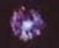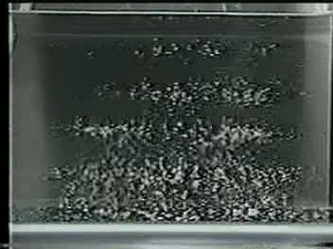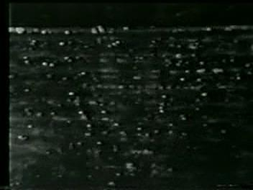At 25 KHz, cavities (microvacuum nuclei) reach their maximum size in about 1/50,000 of a second and disappear in the next 1/50,000 of a second. During cavity growth, a shock wave (positive shock wave) is generated around the cavity from the cavity center to the outside. During annihilation, conversely, a shock wave (negative shock wave) toward the center of the cavity is generated. This is repeated 50,000 times per second.

(New technology) Dissolved oxygen level Low 1mg/l or less

**Photo** 1**:** Gas nebula cavity (faint) 0.5 mm in diameter

**Photo** 2 Spherical nebular cavity (strong) 3-6 mm in diameter

Enlarged view

Enlarged view

(Conventional) Dissolved oxygen High 4-8 mg/l

Ultrasonic cleaning technology utilizes the physical phenomena of cavity creation and annihilation, positive and negative shock waves, for cleaning.

The biggest misconception in ultrasonic cleaning technology is the illusion that the visible bubbles, which are generated when ultrasonic waves are applied to a liquid, are cavities (groups of microvacuum nuclei) generated by the ultrasonic waves described above. Most cleaning solvents other than water contain large amounts of air. In the majority of alcohols, chlorinated solvents, hydrocarbon solvents, and other solvents that can be and are used for cleaning, the oxygen dissolved content is 10 mg/ℓ or higher. When the solvents are irradiated with powerful ultrasonic waves, the pressure change causes the dissolved air to deflate and form bubbles, which burst at the surface of the rising liquid! It does not disappear or shrink in the liquid. This is called ultrasonic gas aeration. The air that has escaped from the liquid is re-dissolved from the liquid surface, and the bubble generation phenomenon by ultrasonic waves, ultrasonic bubbling (or ultrasonic gas aeration), persists. The good news is that the tiny bubbles of air that are generated at this time originate from the vibrating surface of the ultrasound and serve to effectively absorb and block the ultrasound waves. They do not generate the cavities that would otherwise be generated by ultrasound.

**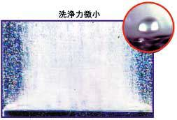In non-water ultrasonic cleaners without measures to reduce dissolved air, more than 99% of the ultrasonic energy disappears at the diaphragm surface!** (Author's measurement)

I think the reason this has not been a problem in non-water cleaning is that the solvents themselves had a certain degree of cleaning power, and thus have been overlooked, but these are not rough times. Cavities generated by ultrasonic waves are high-speed phenomena that are created and extinguished more than 20,000 times per second, and are not visible to the human eye as bubbles. It is not a phenomenon visible to the human eye as bubbles, etc.

## [Photo 3

**When visible bubbles are observed during ultrasonic oscillation, the ultrasonic tank should be considered to have disappeared, as most of the ultrasonic energy is not used.**

**2. Importance of Cavitation Control**

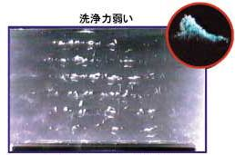The author calls the early ultrasonic cleaners, in which ultrasonic cleaning is considered possible if the object to be cleaned is placed above the ultrasonic transducer, the first generation of ultrasonic cleaners. Then, in response to the importance of cavities in ultrasonic cleaning, ultrasonic cleaners that attempt to control cavities in the ultrasonic cleaning tank are called second-generation ultrasonic cleaners. In this section, we will briefly discuss cavity control in second-generation ultrasonic cleaners. This is the basis of all ultrasonic cleaning system designs, and I am convinced that no new era of ultrasonic cleaning design can be achieved without understanding and practicing this concept.

## Photo 4] Second-generation ultrasonic cleaning system Example of cavitation distribution

## (1) Control of cavitation generation position

In an ultrasonic cleaning tank (the same applies to ultrasonic spray), it is an extremely important basic technology to determine where and how cavitation is generated in a stable manner. The position and shape of the cavitation distribution are determined by the frequency, type of liquid, temperature, depth of liquid, placement of transducers, direction of liquid flow, temperature distribution, etc., as well as the type of material to be cleaned.　The basic distribution of cavitation can be horizontal, vertical, grid, even, or cylindrical, etc., depending on the purpose. The ultrasonic cleaning engineer and the user must clarify the purpose of each ultrasonic bath, and share the distribution of cavitation in each bath and the method of checking it. If the liquid depth is unstable or not theoretically supported, it can be assumed that the basics of cleaning design have not been established.

## (2) Control of cavitation generation density

Cavities in ultrasonic cleaning do not occur on a surface. They occur at points. There is a distance between cavities, and multiple cavities do not occur attached to each other. In general degreasing cleaning, however, the spaces between cavities cause defects in so-called precision cleaning. Therefore, efforts are made to increase cavity density in various ways. Or, efforts are made to increase the distance traveled by the cavities. We are making a lot of efforts to improve the ultrasonic waveform, oscillation efficiency, liquid injection efficiency, output per unit area, and the method of attaching the vibrating elements to reduce the amount of wasted liquid, etc.　The latest ideas for ultra-compact, high-speed, high-density ultrasonic cleaning are an extension of this concept.

## (3) Cavitation impact force control

If the positive and negative impact forces of the cavities are too weak, the cleaning cannot be done; if they are too strong, they damage the object to be cleaned, resulting in defective products. Naturally, if the impact force of the cavity cannot be controlled, it is impossible to design ultrasonic cleaning.　Recently, ultrasonic cleaning objects have become more and more precise and delicate, and the range of cavity selection has become narrower. However, if you have a better understanding of cavities in ultrasonic cleaning, you will have a better understanding of how to control the impact force. In general, the impact force of a cavity is proportional to the pressure of the liquid and inversely proportional to the frequency, vapor pressure of the liquid, and amount of dissolved air.　The impact force of the cavity is proportional to the mass of the liquid that the cavity removes (attracts) in a unit of time, so once the principle is understood, it is clear what to control. Cavitation control in ultrasonic cleaning equipment is an important basic technology in ultrasonic cleaning design. It is impossible to introduce a new ultrasonic cleaning technology without controlling the cavitation.

**3. Third-generation ultrasonic cleaning technology**

Let me now discuss ultrasonic cleaning, the backbone of the new technology. The principle is important, and the applications are unlimited, depending on the object. This is the basic technology that was first discovered and put into practical use by the author in the world during the CFC era, and has been refined under the banner of "eliminating CFC" and developed into today's ultra-strong cleaning, ultrasonic burr, ultrasonic polishing, and ultrasonic high-speed etching (presented by the author at the Washington International Conference in 1993). （Without precise cavity control, this cleaning technology will not produce the required performance, and in some cases will lead to the destruction of the ultrasonic transducer and a significant reduction in cleaning power. Without this technology, the new era of cleaning innovation, so-called precision cleaning technology, would be impossible.

Of course, deburring, polishing, casting sand removal and etching.

The method of controlling the content of gas dissolved in the liquid to maximize and utilize the impact force of cavities generated by ultrasonic waves is called the third-generation ultrasonic cleaning technology and cavitation enhancement system.

**(1) Cavitation enhancement system**

On the premise of an ultrasonic tank that precisely controls cavitation, ultrasonic cleaning equipment that controls the dissolved amount of air in the liquid according to the purpose is called ultrasonic cleaning equipment with cavitation enhancement system (third-generation ultrasonic cleaning equipment). The air content (hereafter substituted by dissolved oxygen content due to the measurement technique) The ultrasonic cleaning technology of the future is inconceivable without the control of the

The future of ultrasonic cleaning will utilize **spherical nebula** cavities. In the era of modern precision processing technology, we need to master ultrasonic cleaning technology and cavitation enhancement system technology that uses these **spherical nebula cavities in** a stable and efficient manner by controlling the amount of dissolved oxygen in the liquid.

**(2) Globular nebula-shaped cavity**

In ultrasonic cleaning in the range of 20 KHz to 10 MHz, we believe that low dissolved oxygen control and the use of spherical cavities are absolute prerequisites for achieving efficient precision cleaning.　Spherical cavities absorb and discharge a large amount of liquid per unit time, and the cavities themselves move at a high speed. Therefore, the cleaning power shows the maximum value under the same conditions, and the diffusion effect (dirt transport effect by cavities) is also the highest.　The air entering from the liquid surface, the gas contained in the liquid itself, and the air on the surface of the object itself should be removed from the ultrasonic cleaning area, and the air content of the liquid around the object and between the object and the diaphragm should always be stabilized at less than half of its saturation value.　This is exactly the same if the ultrasonic irradiation utilizes a cavity, no matter what medium or what flow path it goes through.　How much oxygen (air) content is appropriate depends on the frequency of the ultrasound, the type and temperature of the liquid, and above all, the purpose of the cleaning. In order to use this technique consistently and to utilize the ultrasonic energy efficiently, it is not enough to simply degas the liquid, but it is necessary to strictly observe the aforementioned cavitation control.

**4、Ultrasonic application technology - ultrasonic deburring, ultrasonic polishing**

　　　The application of the giant cavities (micro vacuum nuclei), which can reach 10 mm in diameter, does not stop at simply powerful unmatched ultrasonic cleaning. As a deburring cleaning device after machining and precision molding, it is used in the manufacturing processes of automotive parts, electronic parts, medical parts, etc.　　　**General-purpose ultrasonic deburring and cleaning equipment [Photo 1]**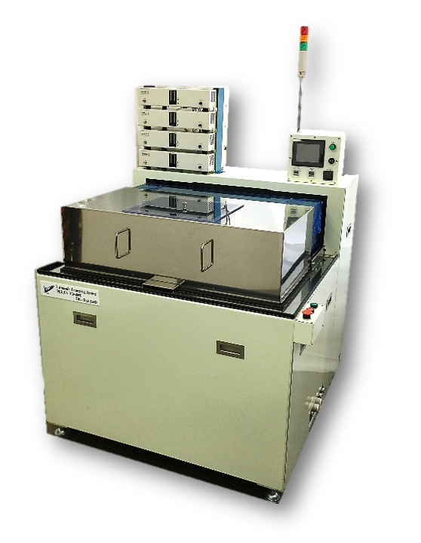

As can be seen from the principle, the target of ultrasonic deburring can be any material. Basically, it can be applied to almost any material, including metals, plastics, ceramics, and composites of these materials, although there are degrees of difficulty. In addition, it is not restricted by shape, the location of burr generation is multi-directional, and tolerance holes on the inner surface can also be targeted.

We are often asked how large a burr can be removed. The size of the burr is not so much relevant, but the thickness of the base of the burr is important. If the thickness at the base of the burr is approximately 0.1 mm, there is a high possibility that it can be removed. For burrs on soft materials such as rubber and silicone, which are difficult to remove due to stress fatigue failure, we will soon release a new technology and begin accepting applications for deburring experiments.

The deburring cleaning time varies from less than 30 seconds to about 30 minutes, with the irradiation time determined by the thickness of the root of the burr and the location of the burr.

The number of pieces processed can be from one to tens of thousands at a time or continuously. **［Photo 2 (4)**

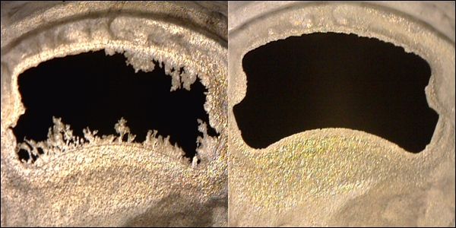PPS molding process burrs [Photo 2]

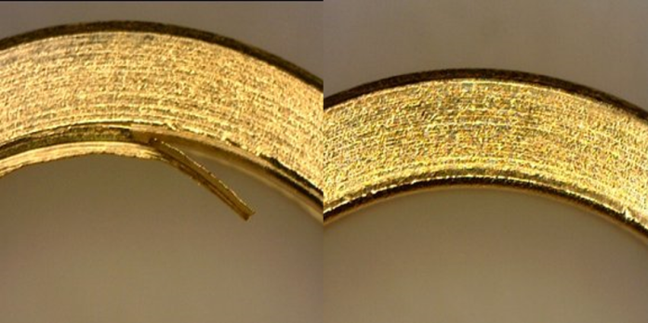 SUS burr [Photo 2]

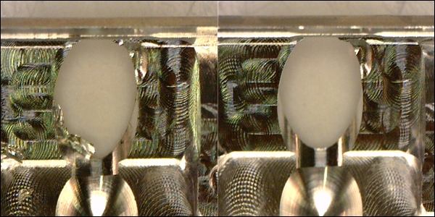Aluminum cutting burrs [Photo 2]

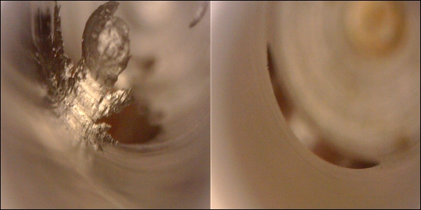Iron Cross-hole burr [Photo 2].

Even if the irradiation time is long, it is often only a few seconds per piece, considering the processing time per piece, since it is automatic and capable of deburring and cleaning a large quantity of pieces.

In addition, while ordinary deburring methods require cleaning after deburring, the ultrasonic deburring/cleaning system performs precision cleaning at the same time, thus eliminating the need for a cleaning process in the next process.

　This powerful ultrasonic wave is also causing innovation in the world of barrel polishing. This is **ultrasonic barrel polishing [Photo 3]**. Here, I would like to talk about ultrasonic applied technology and "ultrasonic polishing," barrel polishing without the use of media, which was thought to be impossible.

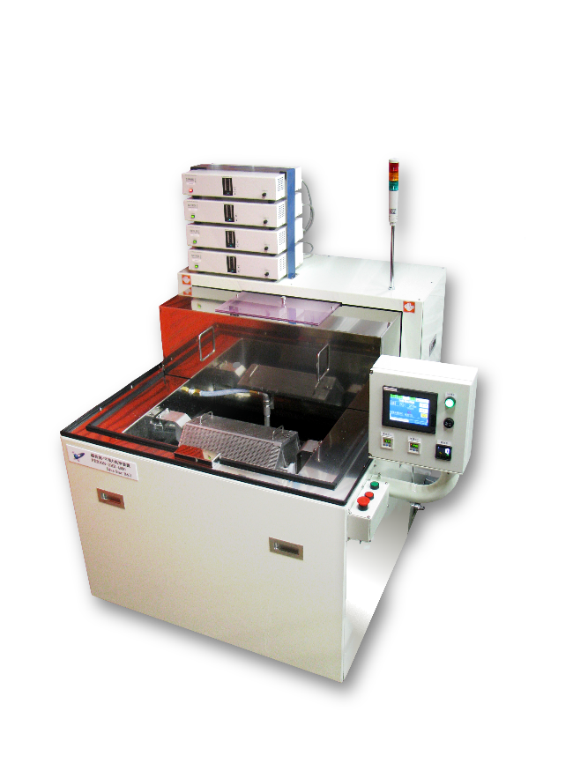Photo 3: Ultrasonic barrel finishing equipment

The rotating cage was initially intended to improve deburring efficiency, but it was confirmed that it was also capable of polishing, and is now standardized as an ultrasonic barrel finishing machine that can perform barrel finishing using only ultrasonic waves and water.

We believe that bearing retainers, precision pressed parts for watches, and other workpieces that currently use conventional barrel finishing can be replaced by media-less ultrasonic barrel finishing without problems.

In the case of normal barrel finishing, polishing is performed by physically rubbing the media and workpiece together, but the media and workpiece are rotating at approximately the same speed. How many times per second do the media and workpiece rub against each other?

In the case of ultrasonic barrel polishing, the cavities are impacted 25,000 times per second. Furthermore, the slow rotation of the hexagonal cage causes co-friction between products, which is more than twice as fast as general barrel polishing, and the same level of polishing ability has been confirmed.

This is ultrasonic barrel polishing, which has realized media-less, which was thought to be impossible.

What does it mean not to use media?

First, media and workpiece separation is no longer necessary, eliminating defects caused by media clogging. Media replacement and management will no longer be necessary, and the heavy labor required due to media will be replaced by light labor. Furthermore, the deburring and polishing speed is several times faster than that of existing barrels (customer evaluation). Furthermore, since precision cleaning is performed at the same time, it can be used for electronic parts with complex shapes that do not tolerate contamination. Since the liquid is not contaminated, wastewater treatment is not required. In addition to city water, pure water, water-soluble rust inhibitors, and hydrocarbon solvents can be used. Drying is also easy and can be fully automated.

Simply eliminating media will reduce labor costs, stabilize quality, reduce expenses, and increase production efficiency.

［Photo 4] shows an ultrasonic deburring, polishing, cleaning, and drying system for precise, complex shapes. Automation is easy, and there are reported cases of ultrasonic deburring, polishing, cleaning, and drying of 3,000 to 25,000 workpieces at a time.

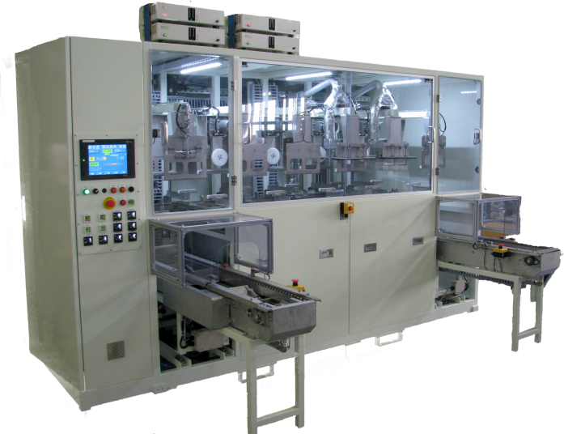［Photo 4] Ultrasonic deburring, polishing, cleaning and drying equipment

**5、Development of ultrasonic cavitation application technology**

　　　The appearance of cavities with a diameter of 10 mm (microvacuum nuclei) means that a completely new means of processing has appeared. It is now possible to remove contaminants from solid surfaces, which is called cleaning, as long as the contaminants are not integrated with the solid. With the help of acids and alkalis, high-speed etching is now possible, and stable removal of surface layers can be calculated.

　　　When it comes to deburring, there are currently a variety of existing deburring methods. It is possible to use ultrasonic deburring for many of these various methods, and at the same time, it is easy to automate the process of cleaning and drying. We even think that the idea of creating burrs that can be removed by ultrasonic deburring may be more useful in reducing costs and stabilizing quality.

　　Ultrasonic barrel finishing can use multiple rotating baskets, large and small, to perform various types of deburring and polishing simultaneously. Automation is also easy.

　　Casting sand removal is now used in parallel with deburring cleaning of engine heads and blocks. Ultrasonic etching removal of aluminum weldment sites on mold surfaces is another new application. Ultrasonic cavity peening, an application of cavity shock waves, has not yet yielded results.

　　The 10-mm-diameter cavity is expected to be used for pulverization, organic synthesis, organic decomposition, sterilization, removal of pests, etc., through high-speed pressure changes inside the microvacuum nucleus group.

　　The following photograph shows an example of a standard, fully automated cleaning, rinsing, deburring, rustproofing, and drying system for automotive parts.

**Yamada full automatic exterior view - not found.**