

To all members of the press

●●March ●●, 2024

Blue Star R&D Inc.

**Establishment of stable production technology for low molecular weight HA4 hyaluronic acid**

**Just by applying it, it penetrates to the dermis to achieve moisturized skin.**

**VC and technology partners sought**

Hyaluronic acid with a molecular weight of over 2 million is converted to a molecular weight of 850 or less by ultrasonic waves.

**(Head office: Sagamihara City, Kanagawa Prefecture; Representative: Miyuki Shibano), the world's only manufacturer of powerful ultrasonic deburring technology, has developed a technology for generating HA4 low molecular weight hyaluronic acid using powerful ultrasonic waves and will commercialize a product that can be packed onto the face during sleep to restore moisture to the skin.**

**Hyaluronic acid has a moisturizing effect and is an important ingredient for skin hydration, but its large molecular weight prevents it from penetrating through the epidermis. HA4 low molecular weight hyaluronic acid penetrates through the skin to the interior, helping to moisturize the skin. Simply apply the pack at night before going to bed. You will be ready for a glowing morning.**

**[URL].<https://blue-galaxy.co.jp/>**

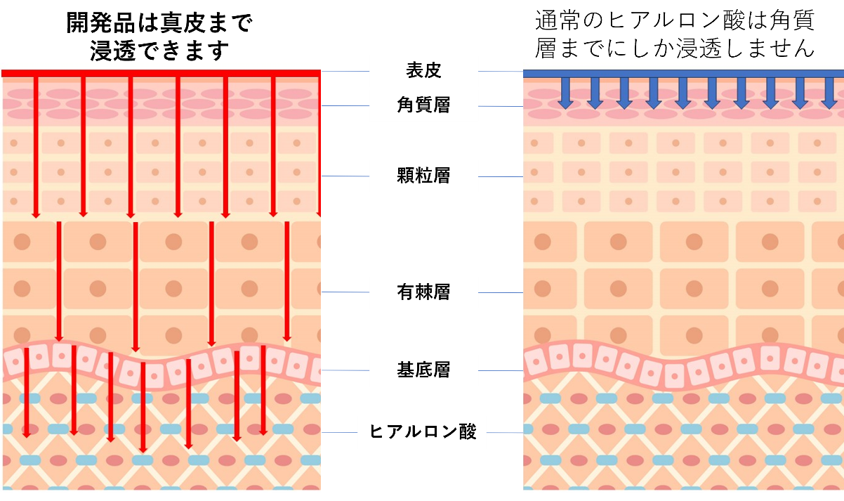

**No expensive enzymes, hydrochloric acid, or organic acids are used to safely produce small molecules of HA4 using powerful ultrasound.**

Every time we look in the mirror, we all think. I want to get back the glowing, moisturized skin of my youth.

Instead of relying on hyaluronic acid injections from cosmetic surgeons, apply HA4 low molecular weight hyaluronic acid to your skin before bed. Hyaluronic acid with a molecular weight of 850 or less passes through the epidermis to the dermis layer, where it works from the inside to restore moisture. Hyaluronic acid with a molecular weight of 1000-3000 protects the epidermis.

Ultrasonic low molecular weight hyaluronic acid contains nothing but water, and nothing is used but ultrasound.

There is no safer way to do this.

All that is needed is a suggestion for easy and safe use.

Let's deliver! Ultrasonic low molecular weight hyaluronic acid HA4.

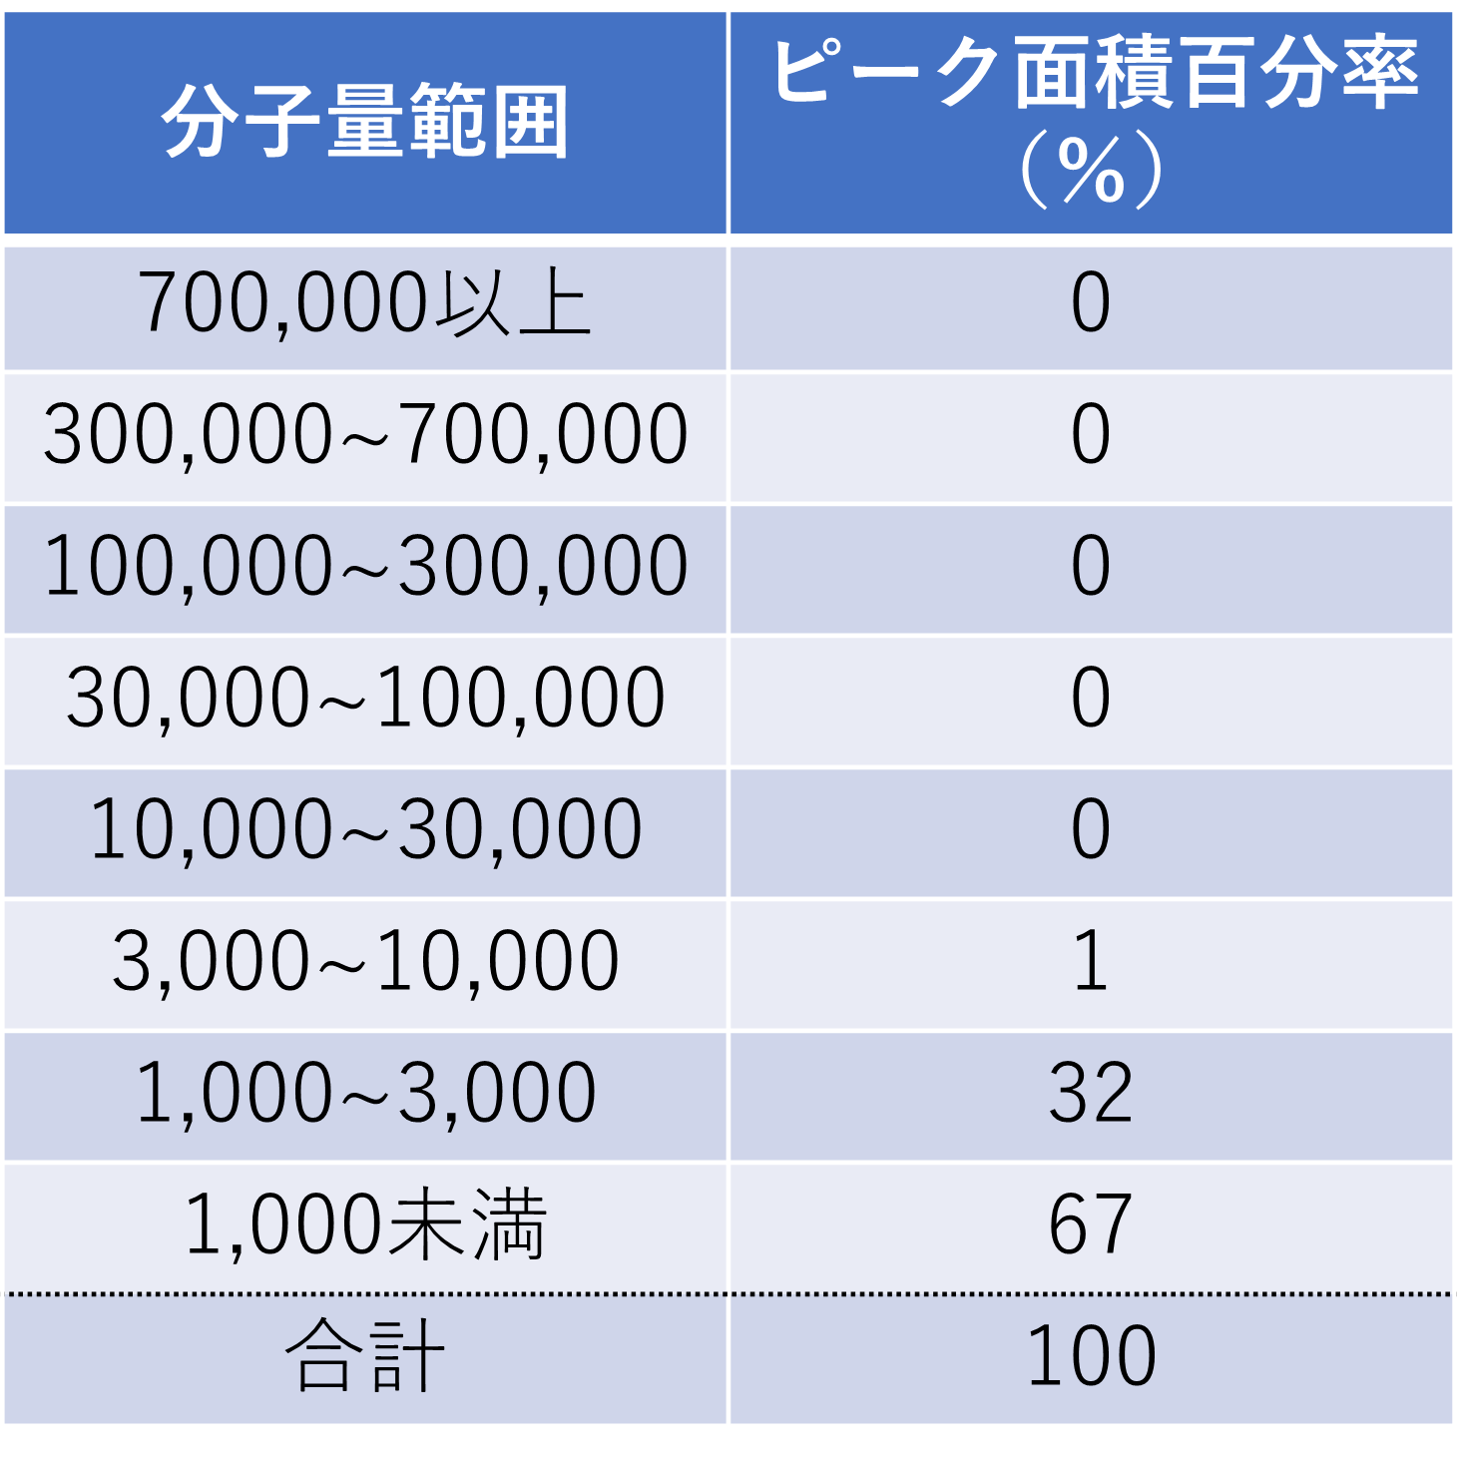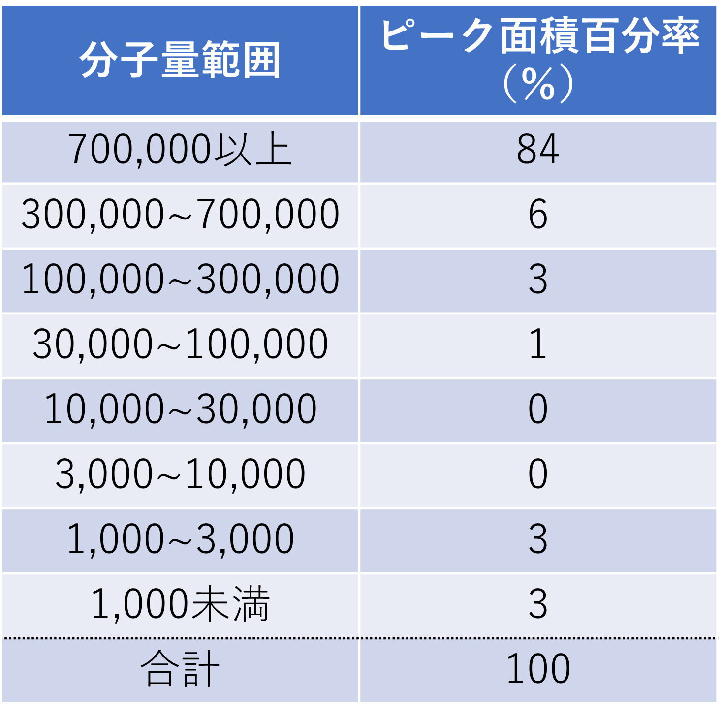**Faster and more effective HA4 hyaluronic acid for radiant, clear skin Dream Cinderella skincare at night**

Molecular weight distribution of hyaluronic acid after sonication (example)

Molecular weight distribution of hyaluronic acid before treatment (example)

**Pinpoint type (This is a planned example. Not yet commercialized)**

**Pinpoint the 　　area where wrinkles are noticeable or where you are worried about cracking before going to bed.**

**Around the eyes, under the eyes, etc.**

Effective size: W5 x L10 x 3 (mm)

Price: 2*** yen / 1 piece, weekly [2*** yen / 12 pieces] monthly [8*** yen / 48 pieces + 4 pieces]

Color: white, pink, yellow

**Large-size type (Planned case study. Large format type (planned example, not yet commercialized)**

**Apply to the left and right cheeks, etc., following the entire area.**

　　　　　　Effective size: W3xL60X2mm

Price: 380 yen per piece, weekly [2*** yen / 12 pieces] monthly [9*** yen / 48 pieces + 4 pieces].

Color: white, pink, yellow

**The world's only one and strongest manufacturer of ultrasonic deburring equipment, which has made it possible to achieve low molecular weight.**

We are the world's only manufacturer of ultrasonic deburring/cleaning equipment, having delivered our products to many of Japan's leading manufacturers, including Toyota Motor Corporation and other Japanese automobile manufacturers. We are an eternal venture company with a delivery record to 14 countries around the world.

During the development of more powerful ultrasound, we discovered that ultrasound can produce cellulose from various biomass and applied for a patent. Bioethanol production using ultrasound is now possible.

At the same time, it meant that organic supramolecular polymers could be reduced to the limit.

　The energy ball (cavity), 10 mm in diameter, generated by ultrasound, is used to 　remove the toxins without the use of hazardous acids or expensive and difficult-to-use enzymes.

It is capable of creating and annihilating organic macromolecules at a rate of more than 20,000 times per second. This ultrasonic technology has made it possible to convert hyaluronic acid, an organic ultra-high polymer, into low molecular weight hyaluronic acid safely, securely, and at low cost, and to introduce it to the global skin care market. Let's work together to spread moisturized skin around the world.

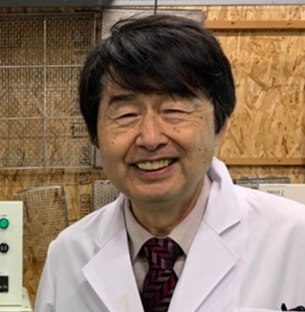**Comments from the Chairman of the Board in charge of development**

　Our company is now overflowing with dreams.

　It has been 35 years since 1990, when we presented our innovative water sonication technology at an international conference in the United States and received the Stratospheric Ozone Protection Award from the U.S. EPA (Environmental Protection Agency). The technology has continued to evolve and is now about to flourish. We are now bringing to you a variety of applications of this powerful ultrasonic cavitation application technology as our platform technology.

　In 　addition to the world's only deburring technology, we also use ultrasound to efficiently convert cedar, corn, and bakas into alcohol, hyaluronic acid into low molecular weight, and nanocellulose fiber. ・・・・ We now have a completely new processing technology.

I am looking for a company and VC who can share my dream with us.

**Past Product Examples and Future Prospects - Innovative Technologies for Earth-Friendly Water**

Our company is an eternal venture. Since our founding, everything we do has been based on world-first products. Our main product, the ultrasonic deburring cleaner, is the only one in the world. Customers from all over the world visit our company every day to conduct deburring experiments. They purchase our equipment based on the results of their experiments. Of course, we use water.

Environmentally friendly technologies must compete with other technologies in terms of cost, and this requires that they be studied and improved. We have been pursuing the impact power of cavities in water (microvacuum nuclei) without any hesitation. The following products are the world's only ones that are recognized by everyone.

**Examples of products developed to date**

Ultrasonic deburring and cleaning machines PERION series; <https://blue-galaxy.co.jp/?page_id=605>

Vacuum pretreatment type deburring and cleaning system MARS series; <https://blue-galaxy.co.jp/?page_id=621>

Ultrasonic deburring and polishing system VEGA MR series; <https://blue-galaxy.co.jp/?page_id=6041>

Fully automatic deburring and cleaning system VEGA-DB series;<https://blue-galaxy.co.jp/?page_id=507>

The BlueShock series of ultrasonic deburring and cleaning systems from one cup;

<https://blue-galaxy.co.jp/katarogu/BlueShock_20231127.pdf>

**Requests to customers in need**

We are committed to providing our customers with the highest quality products and services.

Inquiry URL: <https://blue-galaxy.co.jp/?page_id=12>

**About Blue Star R&D Inc.**

Company Description

　　　　We are a manufacturer of ultrasonic cavitation application technology. Its main products are ultrasonic deburring and cleaning equipment.

We will use our core, powerful and unmatched ultrasonic technology as a platform to expand into a variety of fields.

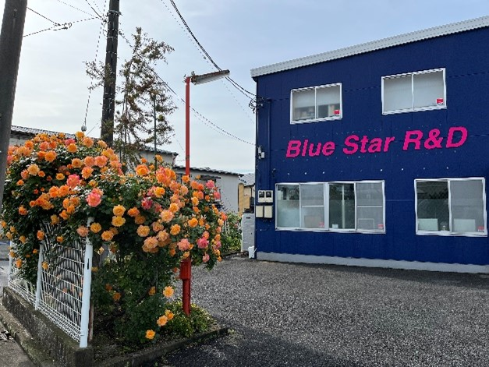**Company Profile**

Company name: Blue Star R&D Co.

Head office: 252-0241

　　　　　　　　　1-31-1 Yokoyamadai, Chuo-ku, Sagamihara-shi, Kanagawa

Representative Director: Miyuki Shibano

Business activities: Development, manufacture and sales of ultrasonic application equipment

Established: April 2010

HP: https:[//blue-galaxy.co.jp/](https://blue-galaxy.co.jp/)

HP in 14 languages URL : <https://blue-impact.biz/>