　　　　　　October 17, 2018

　　　　　　　　　　　　　　　　　　　　　　　　　　　　　　　　　（Blue Star R&D Co.

　　　　　　　　　　　　　　　　　　　　　　　　　　　　　　　　　　Yoshihide Shibano, Chairman

Serialization No. 2

**3. Third-generation ultrasonic cleaning technology**

Let me now discuss ultrasonic cleaning, the backbone of the new technology. The principle is important, and the applications are unlimited, depending on the object. This is the basic technology that was first discovered and put into practical use by the author in the world during the CFC era, and has been refined under the banner of "eliminating CFC" and developed into today's ultra-strong cleaning, ultrasonic burr, ultrasonic polishing, and ultrasonic high-speed etching (presented by the author at the 1993 Washington International Conference). （Without precise cavity control, this cleaning technology will not produce the required performance, and in some cases will lead to the destruction of the ultrasonic transducer and a significant reduction in cleaning power. However, without this technology, we believe that the new era of cleaning innovation, so-called precision cleaning technology, etc., would be impossible.

The method of controlling the content of gas dissolved in the liquid to maximize and utilize the impact force of cavities generated by ultrasound is called the third-generation cleaning technology cavitation enhancement system.

**(1) Cavitation enhancement system**

On the premise of an ultrasonic tank that precisely controls cavitation, ultrasonic cleaning equipment that controls the dissolved amount of air in the liquid according to the purpose is called ultrasonic cleaning equipment with cavitation enhancement system (third-generation ultrasonic cleaning equipment). The air content (hereafter substituted by dissolved oxygen content due to the measurement technique) The ultrasonic cleaning technology of the future is inconceivable without controlling the air content (hereinafter substituted by the dissolved oxygen content due to the measurement technology). When the dissolved oxygen content is more than a few ppm, in other words, in the case of general water and water-based ultrasonic cleaning, **gas nebula cavities** are generated. In the case of **gas nebula cavities**, the speed of movement of the liquid at the time of cavity formation and annihilation is slow, and as a result, the impact force is extremely weak. In addition, the cavities themselves travel only a short distance (within a few millimeters), resulting in severe cleaning irregularities.

(To avoid misunderstanding, the visible microbubbles generated by ultrasonic waves under atmospheric pressure have nothing to do with cavities, but are merely air bubbles that deter and absorb ultrasonic energy. They are simply ultrasonic gas aeration, hardly ultrasonic cleaning.)

Ultrasonic cleaners that utilize gas nebula type cavities are not suitable for the ultrasonic cleaning systems that will compete for precision in the future.　Therefore, ultrasonic cleaners of the future **will** utilize **spherical nebula type** cavities. In the era of modern precision processing technology, we need to master ultrasonic cleaning technology and cavitation enhancement system technology that uses these **spherical nebula cavities in** a stable and efficient manner by controlling the amount of dissolved oxygen in the liquid.

**(2) Globular nebula-shaped cavity**

In ultrasonic cleaning in the 20 KHz to 10 MHz range, we believe that low dissolved oxygen control and the use of spherical cavities are absolute prerequisites for achieving efficient precision cleaning.　Spherical cavities absorb and discharge a large amount of liquid per unit time, and the cavities themselves move at a high speed. Therefore, the cleaning power shows the maximum value under the same conditions, and the diffusion effect (dirt transport effect by cavities) is also the highest.　The air entering from the liquid surface, the gas contained in the liquid itself, and the air on the surface of the object itself should be removed from the ultrasonic cleaning area, and the air content of the liquid around the object and between the object and the diaphragm should always be stabilized at less than half of its saturation value.　This is exactly the same if the ultrasonic irradiation utilizes a cavity, no matter what medium or what flow path it goes through.　How much oxygen (air) content is appropriate depends on the frequency of the ultrasound, the type and temperature of the liquid, and above all, the purpose of the cleaning. In order to use this technology stably and efficiently, it is not enough to simply degas the liquid, but it is necessary to strictly observe the aforementioned cavitation control. In Japan, after the presentation of this technology by the author, many challenges have been made, and as a result, it must be said that a similar product cannot be made yet because of the lack of technology to comply with cavitation control.

**4, Cavitation enhancement system and cavitation distribution**

We would like to see how the cavitation distribution changes with and without degassing. We will then discuss new possibilities for ultrasonic waves when cavitation is accurately controlled by precise deaeration.

1. **Solvent-based ultrasonic cleaning (ultrasonic irradiation)**

Since the dissolved oxygen content is approximately 10 to 20 mg/ℓ or higher, no cavitation occurs, and the dissolved air defoams and floats as bubbles. Since air bubbles reflect and absorb ultrasonic waves, little cleaning effect can be expected from ultrasonic waves. This is called ultrasonic gas aeration.

(1) Oscillation from the bottom

Gas aeration phenomenon caused by ultrasonic waves, with almost no ultrasonic cleaning power. This is a common phenomenon that occurs in chlorinated organic solvents, fluorinated solvents, hydrocarbon solvents, alcohols, acetone, MEK, etc., when 99.9% of ultrasonic waves are eliminated. Ultrasonic cleaning is possible only after these bubbles are eliminated by degassing.

(2) Oscillation from the side

The ultrasonic waves hardly reach the object due to the air bubbles generated.

Incorrect use of ultrasonic cleaning with solvents.

(iii) Oscillation from the bottom and sides

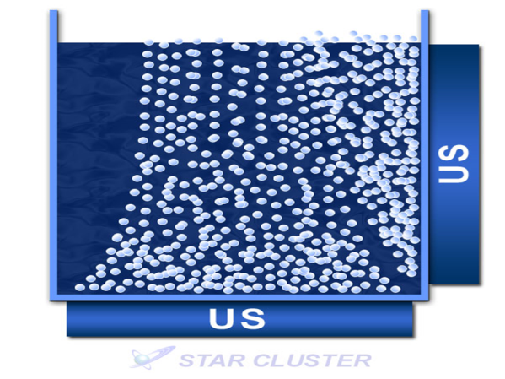

Countless air bubbles are generated, and when viewed from above, air bubbles bursting at the liquid surface are easily seen as cavities, giving the illusion of good ultrasonic cleaning.

(4) Oscillation from both sides

This is also gas aeration by ultrasound.

Expensive ultrasonic bubbling cleaning that does not achieve the desired effect.

**(2) Standard ultrasonic cleaning of water and water-based cleaning agents** Dissolved oxygen content Approx. 5-8 mg/ℓ

(1) Oscillation from the bottom

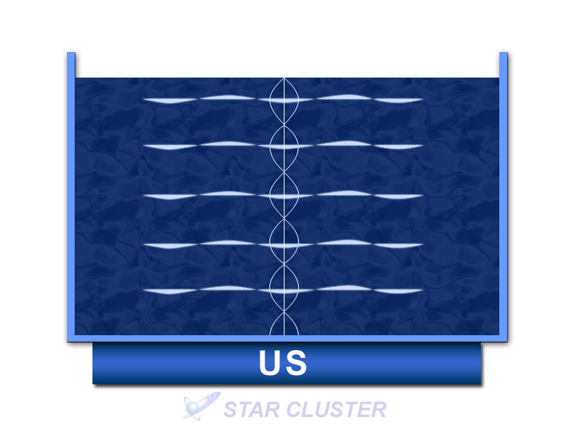

Cavitation distribution of ultrasonic cleaning of water and water systems around the world. The maximum cavity shape is about 0.5 mm in diameter. Horizontally distributed cavitations for degreasing and chip removal.

　　　　(2) Oscillation from the side

If the distance from the diaphragm to the side of the chamber, which is the reflective surface, is precisely matched to the temperature and wavelength, a beautiful vertical stripe cavitation distribution can be obtained.

At this time, rocking the cleaned object up and down will conversely result in uneven cleaning.

(iii) Oscillation from the bottom and sides

Clean grid distribution. Stable ultrasonic cleaning; however, the size of individual cavities is less than 1 mm, and cleaning power is not great.

Degreasing and chip removal level.

(4) Oscillation from both sides

Vertical stripes of cavitation distribution occur nicely. Advanced technology is required to use it.

**(3) Ultrasonic cleaning for dissolved oxygen levels of approx. 3 to 4 mg/ℓ or less**

**New cavitation distribution in cavitation enhancement systems**

1. Oscillation from the bottom

General-purpose cavitation distribution model for precision cleaning.

　　Cavitation distribution for precision cleaning: Numerous spherical cavities of 3φ to 6φ are generated perpendicular to the diaphragm. Cleaning power increases rapidly.

The energy of the cavities is cubic times the diameter.

(2) Oscillation from the side

The reflective surface will be the side of the tank.

(iii) Oscillation from the bottom and from the side

Cavity generation density is extremely high, enabling even and precise cleaning.

If the distance between the reflective side of the tank and the diaphragm is accurately designed and the temperature is controlled, the cleaning power increases dramatically and can be considered an ultrasonic cavitation distribution for precision cleaning.

(4) Oscillation from both sides

Recommend using only if you have mastered the cavitation control technique. If the distance is wrong, the transducer will be destroyed. However, it is capable of very powerful cleaning. We are using 14400W on the opposite side to remove casting sand from engines.

Depending on the amount of dissolved oxygen in the cleaning solution, not only do the individual cavities change from 'bubble => gas nebula type => spherical nebula type', but also the direction of cavity movement and even the size of the cavities change significantly.

　　The third generation of ultrasonic cleaning and cavitation enhancement systems have all the elements necessary for precision cleaning. The cleaning power of cavities in ultrasonic cleaning depends on the cavity diameter. In non-degassed ultrasonic cleaning, cavities are less than 1 mm in diameter; in degassed ultrasonic cleaning, cavities are 3 to 4 mm in diameter, and their energy is much more than 10 times greater, frequency and other conditions being equal. If the appropriate cleaning solution conditions are set, an overwhelming cleaning power completely different from that of conventional ultrasonic cleaning can be achieved.

　In April 2017, we succeeded in reducing the cavity diameter to a maximum of 10 mm. We have succeeded in removing burrs from molding and machining of various materials, and have delivered our equipment to automobile manufacturers, electronic component manufacturers, and medical equipment manufacturers.

In the next issue, I would like to discuss the application of spherical nebula cavities (also called microvacuum nuclei), which can reach 10 mm in diameter, to deburring, polishing, and etching.