Sent out March 2, 2017

**Deburring, polishing, and cleaning can be done with a single machine!**

**Developed for retainers　 Fully automatic, ultrasonic deburring and polishing/cleaning equipment**

VEGA-DB-MR-14-2400

Fully automated **retainer/deburring/grinding** system developed and successfully put into practical use

Deliveries began in April 2017!

Blue Star R&D Co., Ltd. will begin selling the VEGA-DB-MR-14-2400 (hexagonal rotating basket size and dimensions of rotating part: Φ [diagonal part]: 200 [mm], length: 300 [mm]), a fully automatic, ultrasonic deburring and polishing and cleaning device, on October 1, 2012.

# About deburring and polishing.

In the precision molding and machining of electronic and automotive parts, the removal of minute burrs that occur is a very important issue in product quality control. It is no exaggeration to say that it determines competitiveness.

Among them, retainers (retainers) of miniature bearings are typical precision parts with complex and delicate shapes that are not easy to clean, let alone deburr.

The main conventional deburring method is barrel polishing, in which a retainer and compound are placed in a 1 cm stone (grinding stone) called a media and rotated for 30 minutes to 1 hour to deburr and polish. Afterwards, the stone and retainer are separated, and the retainer is cleaned in an ultrasonic cleaner and dried.

This process is extremely hard work and the working environment is harsh, making it extremely difficult to secure young workers. It is also difficult to ensure stable quality.

This **ultrasonic deburring and polishing/cleaning** equipment is a fully automatic type developed for retainers. All you have to do is put 1,000 to 25,000 retainers in the basket, close the lid, and push the switch.

Currently, the only practical application of this technology is in retainers, but we believe that its principle can be applied to a wide variety of small precision machined products other than retainers.

# Performance of deburring and polishing

The retainer rotates slowly while being subjected to the shock waves and vibrations of the powerful cavity, which simultaneously removes burrs, polishes, and cleans.

Hexagonal rotary cages sent from the inlet conveyor are "rough polished and deburred" in the first tank, "finish polished and deburred and cleaned" in the second tank, dried in the third and fourth tanks, and come out from the outlet conveyor.

This process differs from the conventional barrel polishing - ultrasonic cleaning, which is all done automatically.

# [Principle

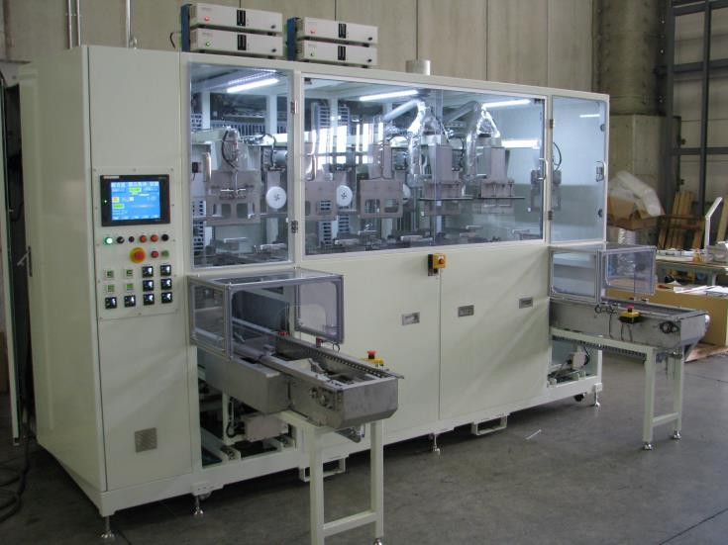Powerful ultrasonic waves are irradiated into water in which dissolved air has been sufficiently removed to generate countless spherical nebula-shaped microvacuum nuclei (cavities). When the vacuum nuclei are generated and annihilated, positive and negative impact forces are generated to remove burrs, which are then polished by vibration.

The target is retainers for miniature bearings and equivalent precision machined and precision molded parts.

The system uses a powerful basic frequency of 25 KHz ultrasonic waves and various ultrasonic frequencies up to 275 KHz for simultaneous multiple-wave oscillation. The shock waves of cavities (groups of micro vacuum nuclei) generated are used to deburr, clean, and dry the target workpiece in a hexagonal rotating basket. The ultrasonic output of the first and second tanks is 2400 W. Only water is used, and the abrasive material is

# Future sales schedule, etc.

No use of any kind. **Rust prevention is also** possible.

Price is approximately 28.5 million yen per set (standard price). Sales are centered on Asia and the United States. The company aims to sell approximately 10 units per year.

**Blue Star R&D, Inc.**  [**http://www.blue-galaxy.co.jp/**](http://www.blue-galaxy.co.jp/)

**1-31-1 Yokoyamadai, Chuo-ku, Sagamihara-shi, Kanagawa 252-0241 Tel: 042-711-7721 Fax: 042-711-7237**

# Specifications

Model VEGA-DB-MR Ultrasonic Barrel Finishing and conventional barrel polishing have almost the same deburring ability. However, it has been confirmed by the optical reflection method that the ultrasonic deburring is superior in terms of polishing ability.

The polished state is achieved to the point that it is "slippery" when touched with a finger.

Hexagonal cage shape (diagonal)200mm length 300mm inner weight 10Kg

Process Inlet conveyor → ultrasonic barrel polishing → ultrasonic barrel polishing → drying → drying → exit conveyor tact time 15 minutes per basket (standard)

Equipment main unit Equipment shape: D:1650[mm] L:2975[mm] H:2050[mm]

Control panel addition Total equipment width L: 3400 [mm] inlet conveyor [external length] L: approx. 820 [ mm

Exit conveyor (external length) L: approx. 820 [ mm]

Weight of equipment : approx. 1850 [Kg] Concrete load capacity : 500 Kg/m2

Gross weight of equipment : approx. 2215[kg] (including liquid) Signal tower : 2250 mm

Attached equipment: Vacuum pump for degassing, vacuum deaeration tower, circulation filter, heat exchanger, chiller [chilled water machine] up/down far motion device, other options: Pure water device (ion exchange resin, activated carbon filter)

**[UTILITY**

|  |  |  |
| --- | --- | --- |
| A. Electricity: Power supply | 3φ 220 [V] 50 [Hz 50 [Hz] : 3φ 220 [V] : 3φ 220 [V] : 3φ 220 [V |  |
|  | Capacity 23 [KW] 26 [KVA] |  |
| B. Pure water water | 3~ 5[ℓ/min] : 3~ 5[ℓ/min] : 3~ 5[ℓ/min  IN 1/2B  Inlet pressure 0.2～0.3[MPa] |  |
| C. Air | 500 [l/min] : 500 [l/min] : 500 [l/min] : 500 [l/min | For horizontal swing operation of the cylinder of the drying tank  and air blow for lifting cylinders and horizontal movement cylinders |
|  | IN 3/4B 0.4MPa |  |
| D. Exhaust air | Approx. 5~10 [Nm3/min] or more | φ100[mm]×1 location |
|  | Static pressure 20[mmAq] | With exhaust fan |
| E. Drainage Water | Drainage Bore Diameter 1B |  |
| F. Chiller. | 3φ 200V 4.6KW 1 unit separately installed |  |

|  |  |
| --- | --- |
| Our introduction video is now available on Youtube!  Learn about Blue Star R&D in 3 minutes! → [Video](https://youtu.be/5iMnzfUcEd8)  A little more detail in 10 minutes! → [Video](https://youtu.be/dtitS6nTbOE)  *Ultrasonic barrel finishing is being demonstrated in our laboratory!  (Reservations required) | **<Company Profile**  Representative: Miyuki Shibano  Establishment] April 22, 2010  Capital] 10,000,000 yen  Business] Ultrasonic Cleaning Ultrasonic deburring equipment  Manufacture and sale of ultrasonic cavitation application equipment  [URL] <http://www.blue-galaxy.co.jp/> |
| **＜Inquiries regarding this matter**  Please contact Blue Star R&D Inc.  [TEL：042-711-7721FAX：042-711-7237E-mail：blue_star@blue-galaxy.co.jp](mailto:blue_star@blue-galaxy.co.jp) | |