Current Status of Ultrasonic Precision Deburring of Plastics

May 10, 2012

Plastic precision molding is a battle against burrs! Barrels, shots, etc. Customers who have tried everything. For plastic deburring, try ultrasonic deburring cleaning.
Following the practical application of the foil deburring system for in-mold molding of cellular phones, DVDs, etc., we have developed a deburring cleaning system for precision plastic injection molding, and have been receiving orders for this system since then, accumulating a track record. Recently, requests for deburring after PPS molding have been rapidly increasing, and we have been busy with the experiments and the results of those experiments to respond to the orders.
In the midst of this rapid economic downturn, we not only sell equipment, but also provide contract ultrasonic deburring and cleaning services to customers who have unstable production or who have not yet received enough orders to purchase equipment. We are now in the process of transforming ourselves from a manufacturer of powerful ultrasonic cleaning equipment to a manufacturer of ultrasonic deburring equipment for a wide range of applications, from various metals and composite materials to plastic deburring. This paper summarizes the current status of plastic ultrasonic deburring and its principles.

Current status of precision plastic deburring
It is no exaggeration to say that precision molding of plastics is a battle against burrs. The reality is that many parts of the burr removal process are still not automated and rely on manual labor. However, even in China, where labor costs are relatively low, rising labor costs are inevitable, and many customers in Shenzhen, Dongyan, and other areas are having difficulty recruiting personnel to remove burrs, which is affecting their operations.
Deburring work, which requires a lot of nerve but does not improve one's skill, is another reason why it is disliked. The days of relying on cheap labor to remove burrs are coming to an end.
For example, at the Tianjin factory of a Taiwanese manufacturer of cell phones, which employs 1 million people worldwide, 80% of the workers are said to be burr workers.
The other day, a newspaper reported that the Chinese government was providing huge support to prevent political instability in China after the Lehman Shock, when the management of the largest foreign-funded company in China deteriorated. (The Chinese government is currently recovering more than it was before the Lehman Shock.) From my experience of inspecting the line after the lecture at the factory in Shenzhen, I was concerned that quality control, as typified by deburring, was still dependent on cheap labor, and that this would further worsen the yield rate amidst the development of precision machining.
It is not unusual to see more than 100 people behind multiple injection molding machines! behind multiple injection molding machines is not uncommon.
Even in China, rising labor costs are inevitable.
In-mold printing, which simultaneously performs plastic injection molding and printing, is a breakthrough in eliminating the painting process from the production line, improving the environment, shortening the process, and providing beautifully printed products. However, the foil used for printing produced burrs, which could only be removed by hand, requiring a large number of deburring personnel.
For this reason, cell phone molding and processing plants were built one after another in countries with low labor costs to reduce the labor cost of deburring. Hungary and Brazil are examples.
However, this problem has been solved.
We have successfully developed and commercialized this foil deburring and cleaning system, and have continued to deliver it to customers.
The majority of plastic precision moldings, however, are not in the field of competing for surface beauty, such as cellular phones, and most of them are moldings that have problems with burrs on the surface of the metal mold. However, even in China, where labor costs are comparatively low, cost competition is progressing, and reliance on human labor means that quality control is unstable.
As precision processing advances, plastic molding is also becoming more and more precise. There are fewer and fewer ways to remove burrs, and fewer and fewer burrs are large enough to be removed by hand.
The market for precision molded plastic parts is huge, far exceeding the market for in-mold molding. The deburring of PPS, in particular, has had to be done manually because of its high pourability and excellent chemical resistance. There has been a worldwide demand for a technology to remove the minute burrs that occur even with these precision molds. We have
finally succeeded in establishing and commercializing a technology for
removing precision molding burrs and processing burrs of precision plastics such as PPS, and we are now actively accepting experiments, enhancing the manufacturing capacity of our equipment, and strengthening our sales.
The basis of our deburring process is basically the same as ultrasonic cleaning, which involves placing a number of precision molded products in a basket, submerging them directly in water, and exposing them to powerful ultrasonic waves.
Since most precision plastic molded products do not release air when placed in water, a vacuum is created once and powerful ultrasonic waves are applied to remove burrs by the impact force generated when cavities made of spherical vacuum nuclei are generated and extinguished.
The removed burrs are quickly filtered out, so there is no fear of re-attachment. Unlike our conventional ultrasonic removal of metal burrs, cavities that generate too strong an impact force cannot be used with plastics. They roughen, fluff, and in some cases puncture the plastic surface. Therefore, Star Cluster has developed a technology that consistently produces cavities that remove only burrs without damaging the plastic surface.
This technology can be applied to a wide variety of plastics.

Principle of ultrasonic deburring cleaning
One example of high-speed movement of gases is gas explosions, but what moves at high speed during the creation and annihilation of microvacuum nuclei is a much denser liquid. The liquid moves at a speed of 50 to 100 meters per second (positive explosion) and then in the opposite direction at a speed of 50 to 150 meters per second (negative explosion). This is repeated over 2,000 times per second. Countless numbers of microvacuum nuclei repeat this process of creation and annihilation in synchronization.
The microvacuum nucleus group = cavity generated near the burr repeats to the burr, i.e., positive and negative impact forces, otherwise expressed as pushing and pulling, over 2,000 times per second. As a result, the micro burrs are instantly blown away. The burrs that are crushed and stuck to the body are subjected to more negative than positive impact forces, i.e., pulling (some engineers still think of the dirt removal mechanism of the cavity as a microjet, which is a one-directional impact wave, but this may only cause the dirt to bite into the body). The dirt is gradually induced and broken (broken) by the same repetitive stress. The rest is the same as in the precision cleaning process.
4800W Vacuum and decompression type ultrasonic deburring chamber upper part  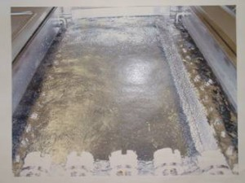 | 2400W Deburring ultrasonic oscillation Status Liquid surface  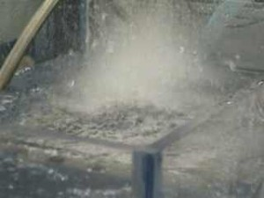
Deburring cavity Surface of diaphragm Occurrence  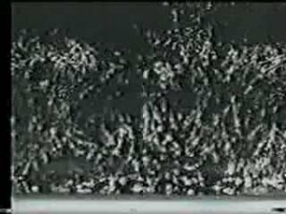 | Titanium nitride coated 2400W deburring ultrasonic transducer  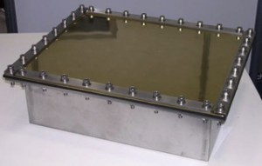
Cavity for deburring High-speed photo 1/1000 sec.

The key points of the ultrasonic deburring system are the ultrasonic transducer and the cleaning tank.
The ultrasonic transducer continuously generates powerful cavities, so the diaphragm itself is continuously subjected to violent impacts. For this reason, the surface of the transducer is coated with 50μ hard chrome plating and also with a titanium nitride coating (see photo). Otherwise, the diaphragm will be destroyed by the cavity
within a few months.
Another area that is often overlooked is the cleaning tank. Like the object to be deburred, the cleaning tank is also subjected to the impact of powerful cavities.
If subjected to a serious impact, even a 3 mm SUS304 cleaning tank can be easily destroyed from the weld zone. Therefore, it is necessary to design and manufacture a safe ultrasonic cleaning tank with precise cavity control to prevent the concentration of shock waves and cavities in the cleaning tank.
［When performing ultrasonic deburring cleaning, the ultrasonic frequency and oscillation method should be changed according to the size of the burrs, the location of the burrs, the shape of the object to be cleaned, and other factors. The size of the ultrasonic transducer should be changed according to the size of the object.
If the impact force of ultrasonic waves is too strong, erosion may occur on the surface of the object to be cleaned, resulting in the destruction of the mirror surface and, depending on the object, the destruction of the product.
To this end, the following measures are being taken

Change of ultrasound frequency
- 25KHz to 275KHz Simultaneous multiple-wave wide-area oscillation
Complex solid shape burr removal, PPS at this frequency
- 50KHz to 275KHZ Simultaneous multiple-wave wide-area oscillation
De-burring of sensitive parts, electronic parts, composite parts

Screen shot of actual ultrasonic deburring
Unfortunately, while we have over a thousand cases, they all belong to our customers. We can only show you a limited number. For
more information, please see the collection of deburring images on our website.

PPS ultrasonic deburring 100-500 pieces at a time
 |  | 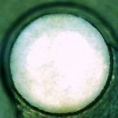 | 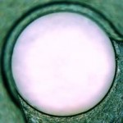
Before deburring ×100  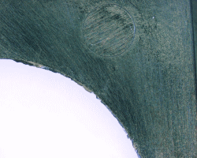 |  | After deburring ×100 5 min.  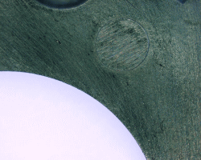

Comparison with other means of ultrasonic deburring
Comparison with other major deburring methods.
Ultrasonic deburring has many unique features.
- Any material can be used.
Various plastics, metals, ceramics, glass, and their composites. Although there are some difficulties, basically most materials can be handled. Rubber is also undergoing gradual technological development.
- It is not restricted by shape, the location of burr generation is multi-directional, and tolerance holes on the inner surface are also covered.
- Unlimited number of pieces. From one to tens of thousands can be processed at a time or in sequence.
- No hazardous materials, etc., are generated. No hazardous materials are used. Use water.
Use hydrocarbon solvents if rust is a problem. Acids, alkalis, and other solvents can be used as needed. Other solvents can be used.
- Burrs can be removed while cleaning without contaminating the cleaned material. Precision cleaning is possible.
- No special technology or skills are required to use it. Easy to automate. Easy to manage.
- The greatest advantage is that micro burrs (micron size) can be removed more quickly and reliably. This is the only means available for future precision machining.
- Even for delicate thin materials [e.g., sheet materials] less than 50 µm in thickness, the technology has been devised to solve the problem. Masking technology is also important.
- Development of composite deburring technology is also in progress. Ultrasonic electrolytic deburring technology is also under development. It can be shared with other existing deburring methods.
- Fewer consumables, e.g. filters. Small running costs.
- The cost of the equipment is a sales strategy issue, as it is the only one of its kind, but in any case, as a system, it is much lower than other competing methods that require precision ultrasonic cleaning after deburring.
- Drying can also be done in a line. Suitable for processing of precision parts.
- The above advantages mean that they can be installed in an environment such as a clean room, eliminating the need for an isolated deburring and cleaning room as with other means, and reducing administrative costs.

