**Advances in Ultrasonic Deburring and Cleaning Technology**

(Deburring of high-performance plastics)

1. **Began in-house production of ultrasonic vibration elements for deburring (BLT)**

In 2020, the new Corona spread from Wuhan had a very big impact on our company.

We do not have sales staff, but wait in the laboratory at our headquarters for customers who come to us with requests for deburring experiments,

The company conducts deburring verification experiments and recommends compatible models.

Due to the spread of the new corona infection, customers from Japan and abroad, who used to come daily, completely disappeared, and at the same time, large ultrasonic vibration elements for deburring, which had been imported, became almost impossible to obtain after April.

In order to overcome this situation, the company has started to establish a distributor system and has also opened five new regional experimental centers in Japan and overseas, which are gradually being operated. Currently, in Japan, the company is headquartered in Okazaki City, Aichi Prefecture, Japan. In China, following Beijing and Tianjin, a subsidiary was established in Dongguan City, Guangdong Province, and is operating an experimental center. The commissioned demonstration room in Bangkok, Thailand, will be expanded in FY2022, and a large deburring machine is scheduled to be installed and operated. As a measure against corona, the company plans to establish test centers in the U.S. and other countries.

Furthermore, the company planned to manufacture in-house a special deburring vibration element, and succeeded in producing a prototype in three months with the cooperation of many business partners and universities. As of last November, all production was switched to in-house production, and semi-automation of the transducer assembly line is currently underway.

This in-house production is now dramatically changing our company. In this paper, I would like to start with this report. It has also had a very significant impact on the deburring of plastics.

**2, Ultrasonic deburring vibrating elements and in-house production impact**

The vibrating elements BLTs for ultrasonic cleaning are still purchased from outside sources.

However, the deburring vibrating element that was developed in-house requires higher amplitude and output than that of the cleaning element, so the piezoelectric element PZT and all the components of the BLT were reviewed from the previously purchased products, and the materials were reformed. Unlike the cleaning elements, the ultrasonic deburring vibrating elements must be made with the smallest possible variation.

For a 4800W ultrasonic diaphragm, we connect 60 elements of 150W each in parallel to resonate. The output of each element is approximately 50%.

The reduction of the variation greatly increases the ultrasonic amplitude of the finished diaphragm and guarantees a stable and long life.

As a result, it became clear that most of the problems that had occurred in the various development processes in the past were not defects in the ultrasonic theory, but were problems that originated in the elements, allowing us to proceed with the development of ultrasonic deburring technology with confidence.

Below are some examples of plastic deburring we have achieved in different fields. We would like to show you the products in a clear picture, but please understand that this is not possible due to the nature of the customer's products.

We will also provide a link to the latest ultrasound cavitation video at the end of this article.

1. **Principle of ultrasonic deburring cleaning**

Before introducing the case study, we will briefly introduce the principle of ultrasonic deburring cleaning.

Powerful ultrasonic waves are irradiated into a liquid such as water. The spherical cavities (micro vacuum nuclei) with a diameter of 6 to 7 mm are generated in the water, and the positive and negative shock waves generated when the cavities are generated and extinguished remove burrs and clean the water at the same time.

　If the spherical cavity is larger than 10 mm in diameter, the impact force is too strong, so it is not often used for plastic deburring. This type is mainly used for deburring metals and ceramics.

The liquid used is water. Usually, city water in the area is used. If the calcium ions in the city water exceed 50 ppm, white stains are likely to occur, so it is recommended that an ion exchange resin be attached to the city water supply port. Of course, if ionic ions are a concern for deburring, pure water should be used.

**Photo 1] Spherical cavity generation state**

**4、Applications of ultrasonic deburring and cleaning technology**

(1) Deburring and cleaning of pipe joints: PPS+GF40%.

　　　Subject model is PWRION-DB-25-4800, basic frequency 20 kHz, output power 4800 W, diaphragm power density 2 W/cm2, liquid is water (city water)

　　　Cage shape is 600 mm (inner width) x 400 mm (depth) x 50 mm (max. 100 mm) in height

　　　Various types of shapes, from 　　　piping elbows and cheeses to very complex shapes.　Unlike casting, many of the shapes are very complex due to the molding process. Manifolds are also increasing. Burrs are found everywhere, including at the joints of molds. The deburring time is 3 to 5 minutes, and the number of pieces processed at one time is 50 to 500 pieces, depending on the size.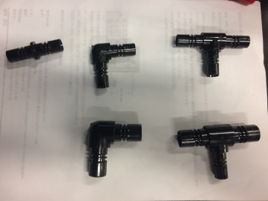

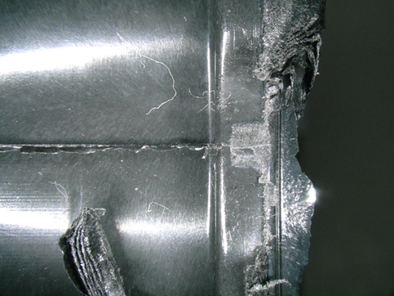　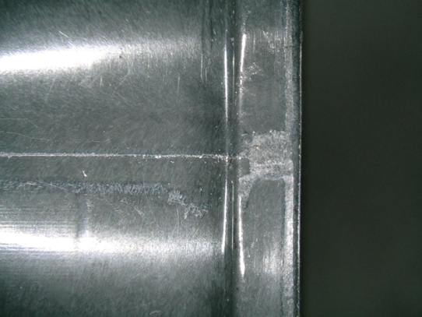

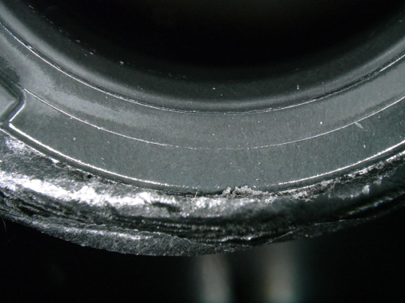　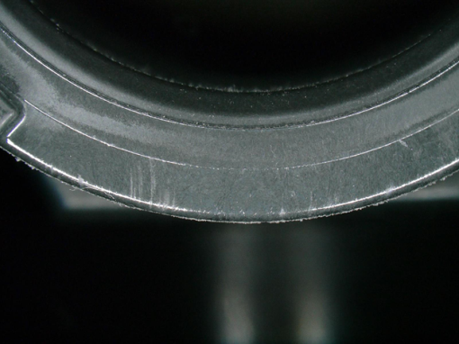

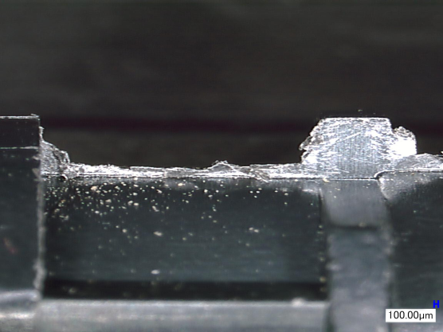　　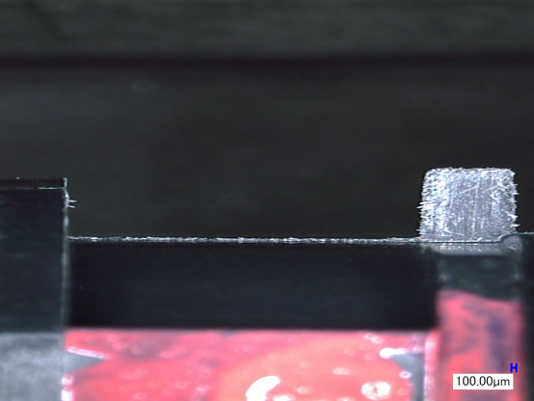

　　　Unlike other methods, ultrasonic deburring uses only water. The burrs are cleaned by powerful ultrasonic waves at the same time as deburring, and the burrs are collected by the fluter, so there is no risk of reattachment. After deburring and cleaning, the machine can dry itself continuously.

　　Typical model PERION-DB-20-4800

　　　　　　［Photo.]

(2) Deburring and cleaning of MT ferrule for optical communication parts: PPS

　　　(Typical example of microhole deburring)

Main target models are PWRION-DB-25-2400 or vacuum pretreatment type MARS-DB-25-2400

Fundamental frequency 25 kHz, output power 2400 W, diaphragm power density 2 W/cm2, liquid is water (city water) or pure water.

Cage shape is 400 mm (inner width) x 300 mm (depth) x 50 mm (height)

Most of our customers are in China. If cleaning of the inside of the fine hole is important, before ultrasonic deburring cleaning

They are using MARS, a vacuum pre-treatment type that removes air by vacuum and then applies ultrasound.

　　白い壁の前に立っている

(3) Deburring and cleaning of large precision molded parts: PPS, ABS, PET + 40% GF

　　　Molded parts such as PPS are becoming larger and larger every year and are used for automotive parts.　Other applications include deburring and cleaning of molded parts for printers and projectors. The main target model is PWRION-DB-20-6000 with a basic frequency of 20 kHz, output power of 6000 W, diaphragm power density of 2 W/cm2, and water (city water) as the liquid.

　　　Cage shape is 800 mm (inner width) x 400 mm (depth) x 50 mm (max. 100 mm) in height

　　　The following photo is an example of an automotive part

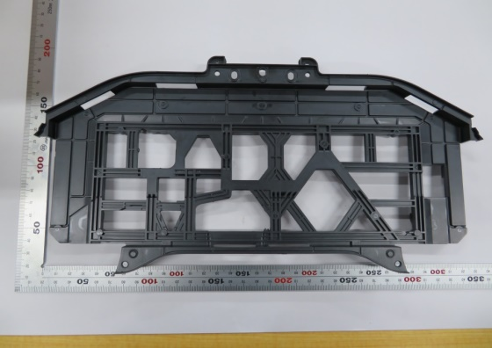

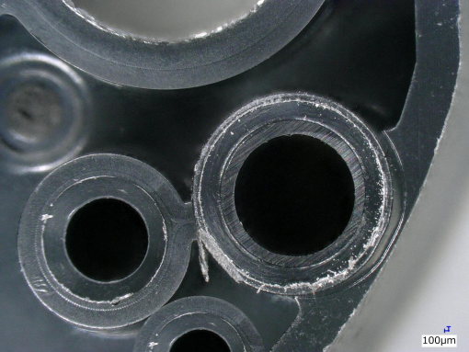　 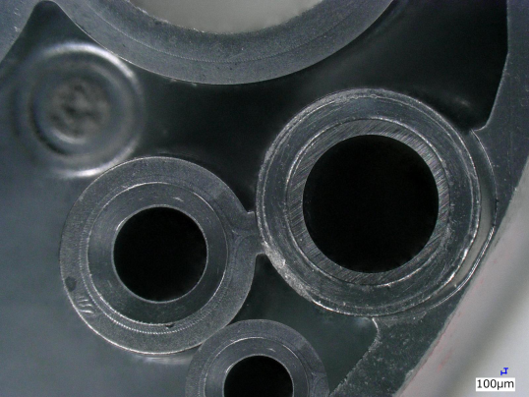

　Plastic deburring/cleaning machines were initially manual deburring/cleaningmachines, but customers' requests for automation have led to an increasing number of inquiries for fully automatic machines with conveyors in front and behind the machine and a dryer. The same type of machine is also used for copper alloy insert molding.

　　Below is an example of VEGA-DB-20-13-4800

(4) Deburring and cleaning of the liner of miniature bearings - PEEK material

　　Requests for deburring of PEEK materials have been increasing year by year, and we would like to address this issue. The same method used for the ultrasonic deburring and polishing equipment for metal miniature bearings and tees can also be used for deburring PEEK material. We have experience in deburring, cleaning, and drying 2,500 pieces at one time, and the equipment is VEGA-DBR-25-13-2400.

(5) Hoop-shaped ultrasonic deburring cleaning - Cu + PPA

Deburring and cleaning machines for lead frames after resin molding have also been attracting attention as the number of deliveries of deburring and cleaning machines for hoop materials has increased. The machine pulls off the protruding and sticking resin parts, cleans them, and dries them before sending them to the next process.

Reference case; SIRIUS-DB-20-6000

(6) Ultrasonic deburring and cleaning of CPU test sockets - PEEK, etc.

In the process of making sockets, it is necessary to drill hundreds to thousands of holes of 100 μm or less, for example, in a substrate such as PEEK material, and many fine burrs are generated at the entrance and exit of the holes and inside. These burrs cannot be removed by conventional means and are removed and cleaned by ultrasonic waves.

Ultrasonically generated cavities (microvacuum nuclei) cause burrs stuck inside as well as around the holes to be removed and cleaned. The specification liquid is pure water.

Currently, most shipments are to the United States. Ultrasonic deburring cleaning of micropores on various electronic substrates and connectors is a future target.

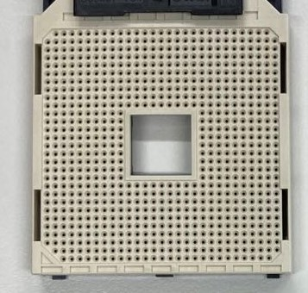

Model PERION-DB-25-6000

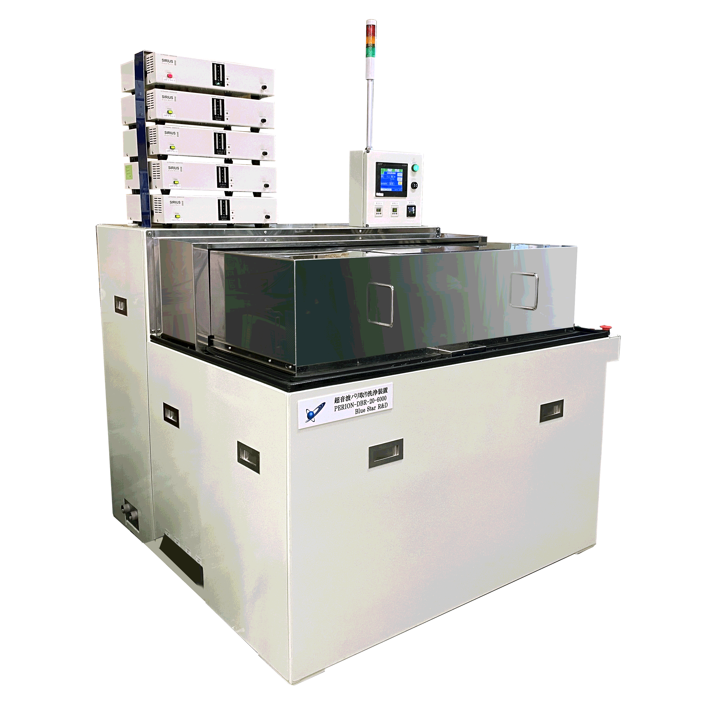

**6, Ultrasonic deburring uses only water.**

　　　　The main features of ultrasonic deburring and cleaning machines are summarized below.

Any ➀ material can be used.

Metals, plastics, ceramics, and composites of these materials Although there are some difficulties, basically most materials can be handled.

(2) Not limited by shape

Burrs occur in multiple directions, including tolerance holes on the inner surface.

(iii) Not limited in number

From one to tens of thousands of pieces can be processed at once or continuously.

(4) No hazardous materials are generated

Do not use hazardous materials; use water.

(5) Powerful cleaning and deburring without contaminating the cleaned material

At the same time, precision cleaning is possible.

(6) No special technique or skill is required for use.

It is also easy to automate and thus easy to manage.

⑧. Low consumables.

Running costs are low because the only consumable part is the filter.

(9) Drying can also be made into a line

　　　　　Deburring, cleaning, and drying can all be automated.

Blue Star R&D conducts demonstration tests in six laboratories in Japan and abroad.

Blue Star R&D Inc.

Yoshihide Shibano, Chairman

〒252-0241

1-31-1 Yokoyamadai, Chuo-ku, Sagamihara-shi, Kanagawa

(TEL) 042-711-7721

(FAX) 042-711-7237

(Email) [shibano@blue-galaxy.co.jp](mailto:shibano@blue-galaxy.co.jp)

**HDB Cavity Video:** <https://youtu.be/-204hrNCj7Q>