　Various filter "vacuum pretreatment type" ultrasonic cleaning equipment

　　　　Disc filters and pleated filters for LCD films, thermal power plants

Turbine air intake HEPA filters, general purpose filters for factory offices, oil filtration filters for ships ・・・・, etc. If you have any questions about cleaning filters, please contact us.

Filters used for filtration, which are a complex combination of metals, synthetic fibers, and non-woven fabrics, are one of the objects that are very difficult to clean by ultrasonic cleaning, regardless of their materials and pore size.

　However, Blue Star R&D has the right ultrasonic cleaning theory to solve these problems and provide a superior cleaning system that is easy for customers to understand.

**\*An example of a fully automated disk filter precision ultrasonic cleaning system for liquid crystals**

　　　　Model Classification MARS-EH Specification liquid Pure water

**Standard Process**

When a workpiece is set on the desk filter, (1) the center of the filter is automatically sealed and chucked at the top and bottom, (2) a vacuum is simultaneously created to remove air from the filter, (3) after removal is complete, a degassing solution is introduced, (4) after immersion, the desk filter is rotated and ultrasonic cleaning is started. (5) At this time, water is first blown out from the inside for a certain period of time. This is backwashing and ultrasonic wave. (6) After a set period of time, the liquid is sucked in, and forward rinsing and ultrasonic rinsing begin.

In other words, after air is completely removed, forward and backwashing are performed simultaneously while rotating and moving up and down.

When a customer's stainless steel wire becomes less than 3μm, the welding part of the stainless steel wire will break even with a wide-range simultaneous multiple oscillator of 25KHz to 275KHz. Therefore, we have succeeded in efficiently oscillating double frequencies of 50KHz to 275KHz from the same oscillation element! The delivered machine will automatically switch the fundamental frequency when a filter with 3μ stainless steel wire arrives.

Of course, if the basic frequency is switched, the liquid depth must also be changed, otherwise not only will the cleaning effect be reduced, but the vibrating elements will be damaged. We **have completed and delivered a fully automatic precision desk filter ultrasonic precision cleaning system that automatically transfers multiple units of** these **single-functional automatic disk filters from a rack using a robot and stores them in the rack after cleaning**.

**\*5 pleated filters simultaneously, vacuum pretreatment type, ultrasonic cleaning equipment**

Model Classification MARS-EH-R

We have also delivered a pleated type 5 chuck vacuum pretreatment, forward and reverse rinsing, and precision ultrasonic cleaning system.

　　[Standard Process]

1. Filter set Horizontal lid in-situ confirmation → Automatic startup PBSW ON
2. Horizontal aluminum vacuum lid closed → Simultaneous chucking of filters → Vacuum processing
3. Deaerated water introduction

→Cavitation enhancement, ultrasonic cleaning, forward rotation, simultaneous backwash, filtration circulation

→Cavitation enhancement, ultrasonic cleaning, reverse rotation, simultaneous forward washing, filtration circulation

→Repeat until time is up.

1. Time up →Lower cleaning liquid level →Open horizontal aluminum vacuum lid
2. Release filter chuck → Take out

　　Photo MARS Example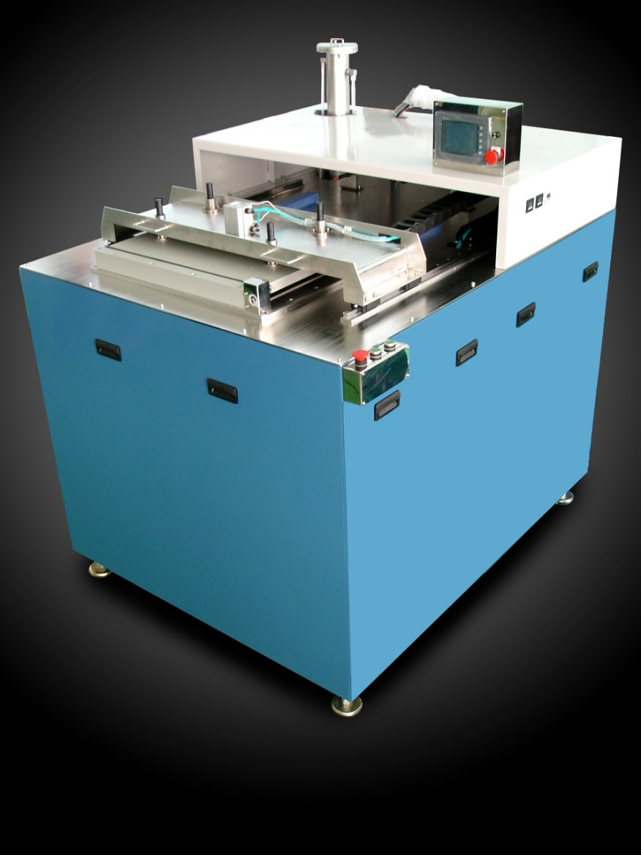

This top photo, flip it left and right, and spread it out a little to the left and right.

**Cleaning and reconditioning of other filters** Proven

　　　　　　　　Filter cleaning technology is an important technology that can greatly help reduce waste by half. Please contact us for more information.