October 27, 2021

PR TIMES Inc.

To all members of the press

**Ethanol is produced from cedar, corn, and sugarcane!**

**Only water and ultrasonic waves are used**

**Successful development of environmentally friendly biofuel production technology**

Produces cellulose without relying on sulfuric acid or sensitive enzymes. Also produces nanocellulose and nanocellulose fibers

**(Head office: Sagamihara City, Kanagawa Prefecture; President: Miyuki Shibano), the world's only manufacturer of powerful ultrasonic deburring technology, has succeeded in developing a low-cost, stable production technology for glucose~ethanol from the world's three largest biomass (Japanese cedar, American corn, and sugarcane residue/bagasse from Okinawa and Brazil) by using powerful ultrasound, The company has succeeded in developing a low-cost, stable production technology for glucose~ethanol.**

**The destructive impact of ultrasound crushes and separates lignin without the use of sulfuric acid or enzymes to extract the cellulose.**

**This is the birth of a technology that can protect the rich forests of Japan and contribute greatly to the world's environmental and food problems.　Patent pending.**

**In addition to cellulose, we have also confirmed the full-scale production of nanocellulose and nanocellulose fibers, dream new materials that researchers around the world are working hard to develop.**

**Help us develop and promote this technology.　We are seeking VC and partner companies.**

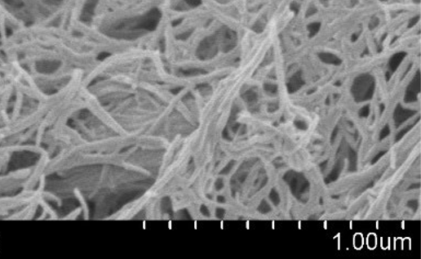**[URL].<https://blue-galaxy.co.jp/>**

**Cellulose is extracted by powerful ultrasound, without the use of delicate enzymes or dangerous sulfuric acid.**

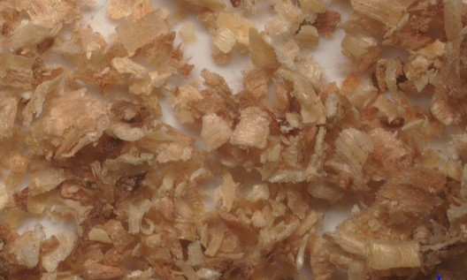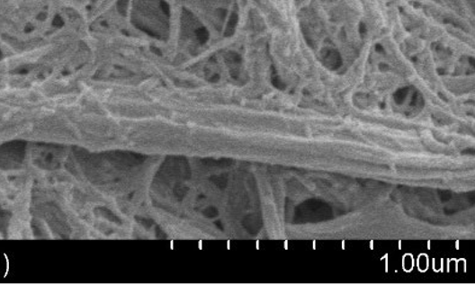　Cedar, corn stalks, and bagasse are mechanically crushed to about 1 mm and immersed in water. The water is then irradiated with powerful, unmatched ultrasonic waves. The ultrasound generates countless vacuum balls of 10 mm in diameter (called cavities) in the water, and these vacuum energy balls are created and annihilated 20,000 times per second. These vacuum energy balls are created and annihilated 20,000 times per second. This generates a violent positive and negative shock wave in the water, which pulverizes the biomass and turns it into sludge. This reaction takes place inside a cylindrical tube, and as the biomass flows through the cylinder, it becomes finer and finer, giving birth to cellulose in the nano range.　(It's like countless mini-Goku awakened in water.)

Cedar, after treatment, 4,000 times

Cedar Before treatment 20 times

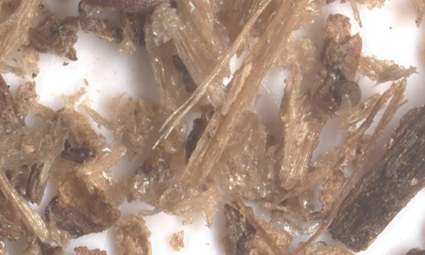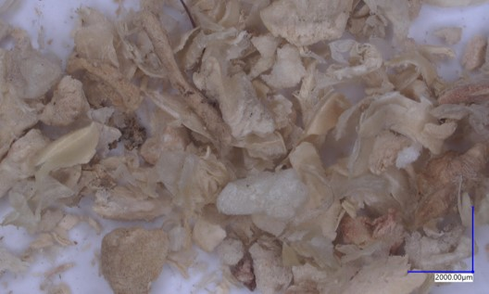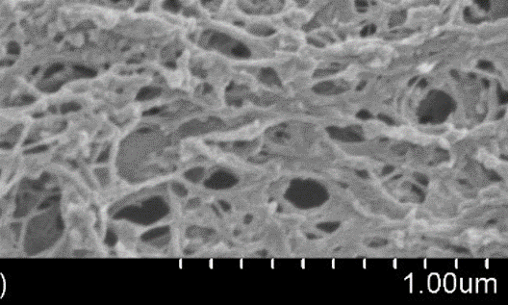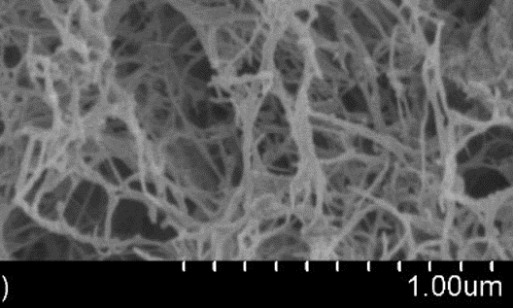

Corn After treatment 40000x

Corn Before treatment 20x

After bagasse treatment, 40000 times

Bagasse Before treatment 20 times

**Bioethanol made possible by the world's only one and strongest ultrasonic deburring manufacturer**

We are the world's only manufacturer of ultrasonic deburring/cleaning equipment, having delivered our products to many of Japan's leading manufacturers, including Toyota Motor Corporation and other Japanese automobile manufacturers. We are an eternal venture company with a delivery record to 14 countries around the world.

During the development of more powerful ultrasound, we discovered that ultrasound can produce cellulose from various biomass and applied for a patent. Bioethanol production using ultrasound is now possible.

At the same time, it meant that organic supramolecular polymers could be reduced to the limit.

　This means that organic macromolecules can be miniaturized without the use of 　hazardous acids, expensive and difficult-to-use enzymes.

Nano-grinding is possible in all fields. Perhaps even synthesis.

One of the applied technologies is the successful HA4-lowering of hyaluronic acid, an organic ultra-high molecular weight. We will also enter the skincare business to improve wrinkles and restore skin moisture.

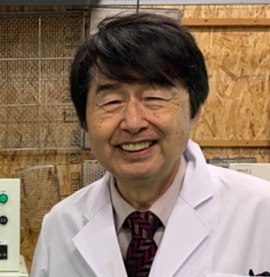**Comments from the Chairman of the Board in charge of development**

Our company is now overflowing with dreams.

　In 1990, he presented his innovative water sonication technology at an international conference in the United States.

It has been 35 years since the U.S. Environmental Protection Agency (EPA) awarded the company its first Environmental Protection Award. Now, the technology is about to blossom. The intense ultrasonic cavitation application technology is now being used as a platform,

We deliver various dreams to our customers.

Nano miniaturization and ultrasonic production of new materials, both inorganic and organic, will begin.

I am looking for a company and VC who can share my dream with us.

**Past Product Examples and Future Prospects - Innovative Technologies for Earth-Friendly Water**

Our company is an eternal venture. Since our founding, everything we do has been based on world-first products. Our main product, the ultrasonic deburring cleaner, is the only one in the world. Customers from all over the world visit our company every day to conduct deburring experiments. They purchase our equipment based on the results of their experiments. Of course, we use water.

Environmentally friendly technologies must compete with other technologies in terms of cost, and this requires that they be studied and improved. We have been pursuing the impact power of cavities in water (microvacuum nuclei) without any hesitation. The following products are the world's only ones that are recognized by everyone.

**Examples of products developed to date**

Ultrasonic deburring and cleaning machines PERION series; <https://blue-galaxy.co.jp/?page_id=605>

Vacuum pretreatment type deburring and cleaning system MARS series; <https://blue-galaxy.co.jp/?page_id=621>

Ultrasonic deburring and polishing system VEGA MR series; <https://blue-galaxy.co.jp/?page_id=6041>

Fully automatic deburring and cleaning system VEGA-DB series;<https://blue-galaxy.co.jp/?page_id=507>

The BlueShock series of ultrasonic deburring and cleaning systems from one cup;

<https://blue-galaxy.co.jp/katarogu/BlueShock_20231127.pdf>

**Requests to customers in need**

We are committed to providing our customers with the highest quality products and services.

Inquiry URL: <https://blue-galaxy.co.jp/?page_id=12>

**About Blue Star R&D Inc.**

Company Description

　　　　We are a manufacturer of ultrasonic cavitation application technology. Its main products are ultrasonic deburring and cleaning equipment.

We will use our core, powerful and unmatched ultrasonic technology as a platform to expand into a variety of fields.

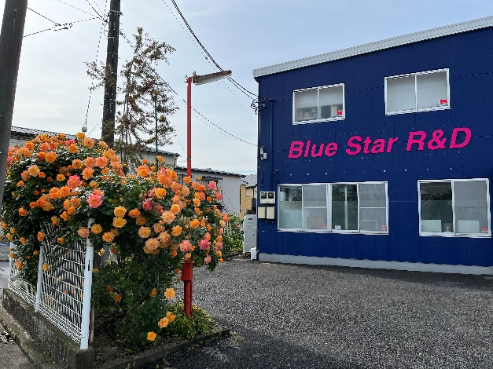**Company Profile**

Company name: Blue Star R&D Co.

Head office: 252-0241

　　　　　　　　　1-31-1 Yokoyamadai, Chuo-ku, Sagamihara-shi, Kanagawa

Representative Director: Miyuki Shibano

Business activities: Development, manufacture and sales of ultrasonic application equipment

Established: April 2010

HP: https:[//blue-galaxy.co.jp/](https://blue-galaxy.co.jp/)

HP in 14 languages URL : <https://blue-impact.biz/>