　　1000 words or less

**Metal 3D precision molding Removal technology of internal residual metal powder**

　　　Powerful ultrasonic waves are used to generate countless spherical nebula cavities (micro vacuum nuclei) of 10 mmΦ in diameter, and the positive and negative shock waves generated at that time are used to remove residual metal powder inside the cavity.　　　　　　　　　　　　　　　This world-first technology will be introduced.

**［Principle of removal of internal residual fines]**

　When the amount of dissolved oxygen in water is reduced and the water is irradiated with ultrasound, spherical nebula-shaped cavities (microvacuum nuclei) are generated.

The metal 3D molded product is immersed in water and irradiated with powerful ultrasonic waves. The amplitude of the ultrasonic transducer is adjusted to generate a myriad of spherical nebula-shaped cavities (micro vacuum nuclei) with a diameter of 10 mmΦ on the surface.

One cavity is composed of many smaller vacuum nuclei (called microcavities). Hence, I also refer to cavities as microcavities.

Microcavities are repeatedly produced and annihilated synchronously, without changing their position from the central core of the cavity.

The following photograph is an image of a cavity (a group of microvacuum nuclei) with a diameter of about 10 mmφ taken by a high-speed camera with a resolution of 2.1 millionths of a second.

The frequency of the ultrasound is 20 KHz.

[Cavity generation and cavity disappearance]

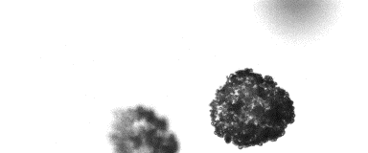

1/160000 sec.

4/160000 sec

2/160000 sec

3/160000 sec

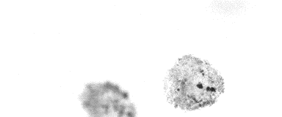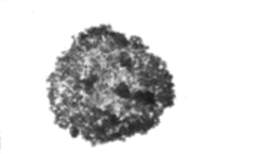

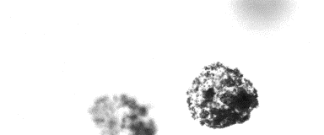

5/160000 sec

6/160000 Seconds

7/160000 Seconds

8/160000 sec

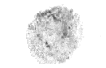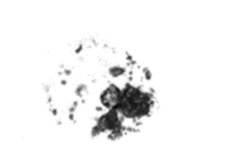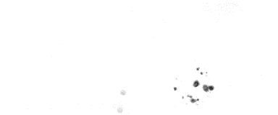

Cavities are created and annihilated more than 20,000 times per second. When cavities disappear, a strong negative shock wave is generated, i.e., an attractive force, which pulls away the fines on the metal surface. When cavities are generated, conversely, a positive shock wave is generated, i.e., a force that pushes the fines onto the metal surface.

Positive and negative shock forces are greater for negative shock waves. This is because atmospheric pressure increases the dissipation speed of the negative shock wave. This difference in speed is the reason why ultrasonic cleaning can remove dirt. Without the difference in the speed of the positive and negative shock waves, ultrasonic cleaning would not be possible. It would merely serve as a concentration diffuser.

The difference in velocity between the positive and negative shock waves is slight, but this, when repeated 20,000 times per second, causes a significant change. In other words, in the case of metal 3D, it can be the force that removes the metal powder that is embedded in the surface layer of the outer shell surface.

The ultrasonic waves then penetrate into the metal 3D without significant attenuation, generating cavities in the interior space with a diameter of 3 to 6 mmΦ. The shape depends on the size of the inner cavity; for 20 KHz ultrasound, cavities are generated in 40,000ths of a second and disappear in the next 40,000ths of a second.

　If a cavity with a diameter of 3 mm Φ is generated in a space filled with degassed water with an internal diameter of 2 mm Φ, high-speed movement of water at a speed of 500 m/s or more occurs to a position about 18 mm to the left or right from the generated position.

That is, the residual metal powder inside the cavity generation area is subjected to a high-speed movement of water of approximately 500 m/s or more (positive shock wave) in 1/40,000 of a second, and in the next 1/40,000 of a second, it is subjected to a high-speed movement of water of approximately 500 m/s in the opposite direction of the first (negative shock wave). This phenomenon occurs in any flooded space inside a metal 3D molding.

　　This is repeated 20,000 times per second. The repetition of the shock wave pulls off the residual fines in a short time, and they are easily discharged by water flow.

　　By controlling the water flow rate, it is highly possible to reduce the internal surface roughness Ra by utilizing the high-speed reciprocating motion of residual metal powder at a speed of 500 m/sec.

　　Attached below is an image.

　　　Before cleaning x100 With fines After cleaning x100 Without fines After cleaning x20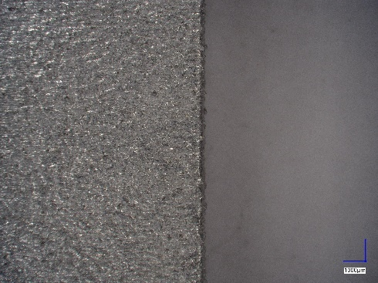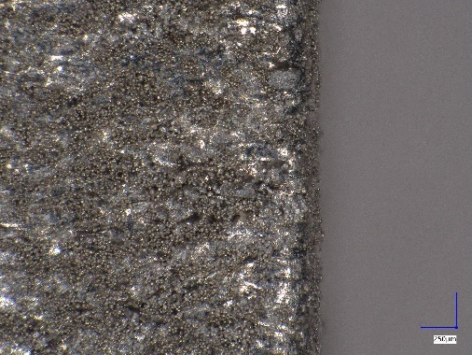

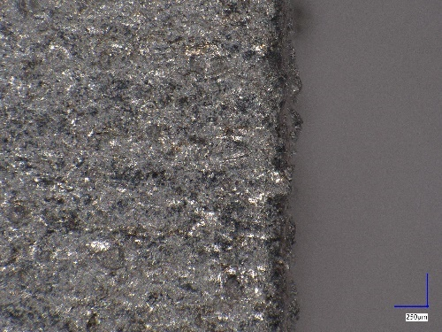

In this way, metal powder inside complex micro piping and lattice structures is easily removed by generating numerous spherical nebula-shaped cavities inside. Removal of internal metal powder from rocket combustion nozzles is also easy.

**［Example.]**

　　　To facilitate understanding of the principle, an example of an internal fines removal device is shown below.

The figure below shows a cross-sectional view of the ultrasonic tank.

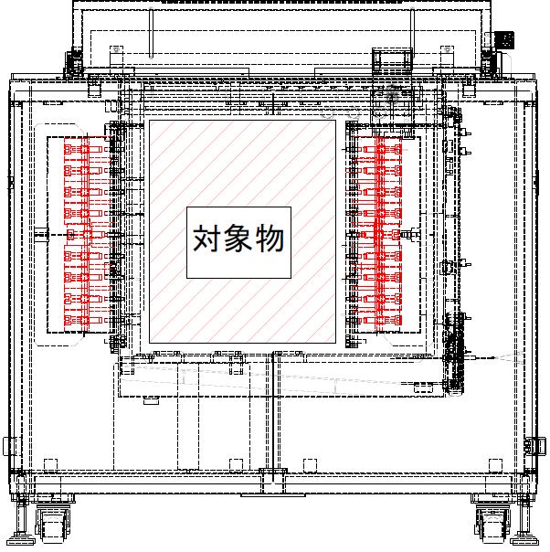

　Ultrasonic vibration plates are placed on both sides of the ultrasonic chamber. Place the target metal 3D product in the center of the ultrasonic chamber.

Ultrasonic waves are irradiated. The ultrasonic waves on both sides are phase-matched and oscillated synchronously. As a result, ultrasonic waves penetrate to the inside of the object, generating numerous spherical cavities. Water is then passed through these cavities and the metal powder is discharged to the outside. This device is designed so that the diaphragm can be moved according to the size of the object and set at the optimum resonance position.

The size of the target metal 3D molding can be several meters or more. In this case, the ultrasonic diaphragm moves in parallel.

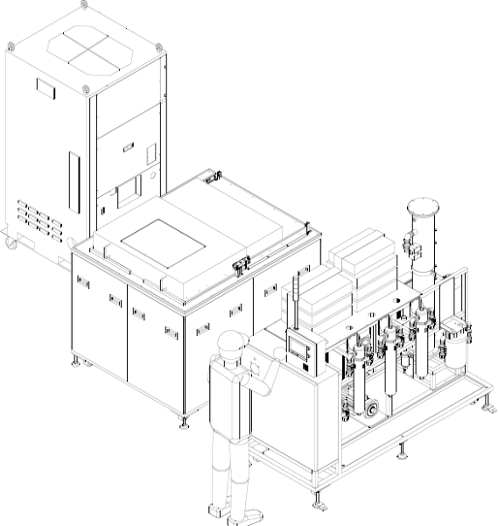

　The figure above is an example of the configuration of the necessary equipment for metal 3D metal powder removal: ultrasonic tank, chiller, ultrasonic vacuum degassing tower, and filtration machine. Since ultrasonic cavities eventually convert to heat, a chiller is essential to control the rise in water temperature and to maintain the optimum temperature.

　　We are pleased to inform you of the removal technology for internal residual metal powder.

　Cavities are not only used for cleaning and deburring, but are also evolving toward new possibilities, such as the decomposition of organic polymers, the generation of ethanol from lignocellulose, and the production of nanocellulose fibers.