（Blue Star R&D Co.

New deburring and cleaning equipment for micro-holes in CPU sockets, etc.

Blue Star R&D, a manufacturer of ultrasonic deburring and cleaning equipment, will release two new ultrasonic deburring and cleaning equipment: (1) MARS-HDB-20-4800 and (2) MARS-HDB-20-6000, which use ultrasonic waves to remove burrs generated during the fine processing of boards such as CPU sockets.

Place a number of sockets in the basket, place the basket on the cleaning table, close the lid, and press the start SW. The basket is lowered into the vacuum pretreatment chamber, and the air in the micropores is completely removed. Next, the basket is immersed in the ultrasonic chamber, where the burrs in the micropores are removed and cleaned by the positive and negative shock waves of cavities (microvacuum nuclei) 7 to 10 mm in diameter generated by the powerful ultrasonic waves.

The liquid used should be pure water to prevent stains caused by calcium and other substances contained in the water.

After ultrasonic cleaning, the basket returns to its original position and is sent to the next process, such as drying.

If the size is 30 mm square, ➀240 or ➀320 pieces can be deburred and cleaned simultaneously in 2 minutes.　　Substrates are often made of PEEK, PPS, etc. The system can also handle cases where fluorinated resin PTFE is included. Removed burrs are immediately removed from the ultrasonic chamber and filtered out with a 20μm + 0.5μm filter. In addition to Japan, the product will be available in the United States, Taiwan, and China, with shipments scheduled to begin in November.

Photo [1] CPU socket (example) The upper left socket in the lower left photo is processed and placed.

Please discuss.

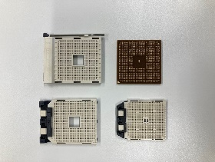

Photo [2] MARS-HDB-20-4800 The touch panel currently in the factory is in the front right corner, please include a photo of the machine below.